|  |  |
| --- | --- |
|  | **FPT ACADEMY INTERNATIONAL**  **FPT – APTECH COMPUTER EDUCATION** |

**Centre Name: ACE-THUDUC-1-FPT**

**Address: 391A Nam Ki Khoi Nghia District 3, Ho Chi Minh City, Viet Nam.**

VENUS HANDICRAFTS

|  |  |  |
| --- | --- | --- |
| **Supervisor.** | Mr. Nguyen Phat Tai | |
| **Batch.** | T3.2307.E1 | |
| **Group.** | Group 7 | |
| **Serial No.** | **Enrollment Number** | **Student Name** |
| 1. | Student1491504 | Nguyen Minh Triet |
| 2. | Student1491723 | Tran Quoc Viet |
| 3. | Student1491479 | Nguyen Khanh |
| 4. | Student1491647 | Le Thi Ngoc Han |

NOV-14-2023

**This is to certify that**

**Mr/Ms:**

Nguyen Minh Triet

Tran Quoc Viet

Nguyen Khanh

Le Thi Ngoc Han

**has successfully designed & developed**

eProject: Handicrafts website

**Submitted by: Le Thi Ngoc Han**

**Date of issue: 14-Nov-2023**

**Authorized Signature: Han**

**TABLE OF CONTENTS**

ACKNOWLEDGEMENT 4

SYNOPSIS 4

PROBLEM DEFINITION 4

CUSTOMER'S REQUIREMENTS SPECIFICATIONS (CRS) 4

Business/Project Objective: 4

Hardware/ Software Requirements: 5

SCOPE OF THE WORK (IN BRIEF) 6

Architecture and design of the system 7

Diagram of the website 8

TASK SHEET REVIEW 1 9

SITE MAP 10

MOCK OF THE WEBSITE 11

1. HOMEPAGE 11

2. PRODUCT 12

3. BRAND 13

4. GALLERY 14

5. FAQs 15

6. COMPARE 16

7. CONTACT US 17

8. ABOUT US 17

TASK SHEET REVIEW 2 18

WEBSITE DESCRIPTION 19

1. Home Page: 19

2. MenuDropdown1 21

3. MenuDropDown2 22

5. BrandsPage 24

6. ProductDetail 25

7. Compare 26

8. Sitemap 27

9. FAQs 28

10. AboutUsPage 29

11. ContactPage 30

12. Gallery 31

SOURCE CODE 31

TASK SHEET REVIEW 3 38

# ACKNOWLEDGEMENT

On behalf of all members of Team 7, I would like to thank all of you for your hard work and support to successfully complete this eProject. Especially Mr. Nguyen Phat Tai, our teacher, has helped us a lot since the day we started studying at FPT Aptech. With this eProject, the Teacher guided us very enthusiastically and heavily. Thanks to his guidance, we were able to complete this project. Additionally, I would like to thank all team 7 members, each team member worked continuously for 4 weeks to complete this project. Last but not least, we would like to thank our family for always supporting and creating the best conditions for us to focus on the project and believe in the dreams we pursue.

# SYNOPSIS

VENUS HANDICRAFTS is selling various types of Handicraft. The company advertises by distributing the pamphlets, advertising on television and so on. Due to rapid development in internet field, the company decides to launch a website where people will get all the information about the various products available with them easily. You are supposed to create a website for them with the below mentioned requirement specifications.

# PROBLEM DEFINITION

The Web site is to be created based on the following requirements.

1. The Home Page should be created with proper sections, graphics and with a suitable logo
2. Link on the home page must be included such as Home, About Us, Gallery, Contact information, Handicrafts products,
3. The look and feel of the project must be made user friendly and uniformity in the color combination must be maintained.
4. Handicrafts such as:
   * Iron Handicrafts
   * Glass Handicrafts
   * Brass Handicrafts
   * Wood Handicrafts
   * Aluminium Handicrafts
   * Handicraft Decorative
   * Tables wares
   * Home Décor
   * Candle Accessories
   * And other additional products
5. Navigation of the project must be made smooth.
6. Site Map
7. Gallery
8. FAQs

# CUSTOMER'S REQUIREMENTS SPECIFICATIONS (CRS)

**Client: Venus Handicrafts**

### Business/Project Objective:

The Objective of this program is to give a sample project to work on real life projects. These applications help you build a larger more robust application.

The objective is not to teach you JavaScript/Dreamweaver but to provide you with a real life scenario and help you create basic applications using the tools.

You can revise the chapters before you start with the project.

This project is meant for students who have completed the module of ***HTML5.*** These programs should be done in the Lab sessions with assistance of the faculty if required.

It is very essential that a student has a clear understanding of the subject. Students should go through the project and solve the assignments as per requirements given.

Kindly get back @ [eprojects@aptech.ac.in](mailto:eprojects@aptech.ac.in) in case of any doubts regarding the application or its objectives.

**Input to the system:**

* + - * Browsing products based on brands, type of appliances..

**Output from the system:**

* A menu that will categorize all the functions of the site.
* Display the list of available albums category wisely.
* Perform the brief comparison by showing 2 products of the same type with their details.
* Site should be able to provide brief introduction/history about the company under About Us page.
* The location of the company is in Contact Us page.
* Besides the above requirements, the site should have look and feel as per the industry standards.

**Expected delivery date:** 14-NOV-2023.

**List of deliverables:**

* + - * Document Word.
      * User Guide.
      * Source code.

### Hardware/ Software Requirements:

**Hardware**

* + A minimum computer system that will help you access all the tools in the courses is a Pentium 166 or better
  + 64 Megabytes of RAM or better

**Software**

* + Notepad/HTML editor/CoffeeCup
  + Angular / Angular JS / React / BootStrap
  + Dreamweaver / Figma
  + MS IE / Chrome / FireFox / Netscape /MS Edge

# SCOPE OF THE WORK (IN BRIEF)

**The team has discussed and has agreed about the website layout as shown briefly below:**

1. **Homepage**: Showing brief introduction about the company and type of products that it is selling.
2. **About Us**: Introducing the history, achievement and further information about the company.
3. **Gallery:** Allowing you to create a list of products for customers to refer to and order
4. **Contact information**: Showing the contact information of the company such as address, location map, mobile, fax, email.
5. **Handicraft Products**: Containing its products with their details and images categorized by type.
6. **Categories:** Organizing and classifying products into similar groups.
7. **Contact Us**: Showing the contact information of the company such as address, location map, mobile, fax, email.
8. **FAQs:** Listing of questions and answers that are commonly asked about a particular topic.
9. **Site map:** Listing all of the pages on a website.

# Architecture and design of the system

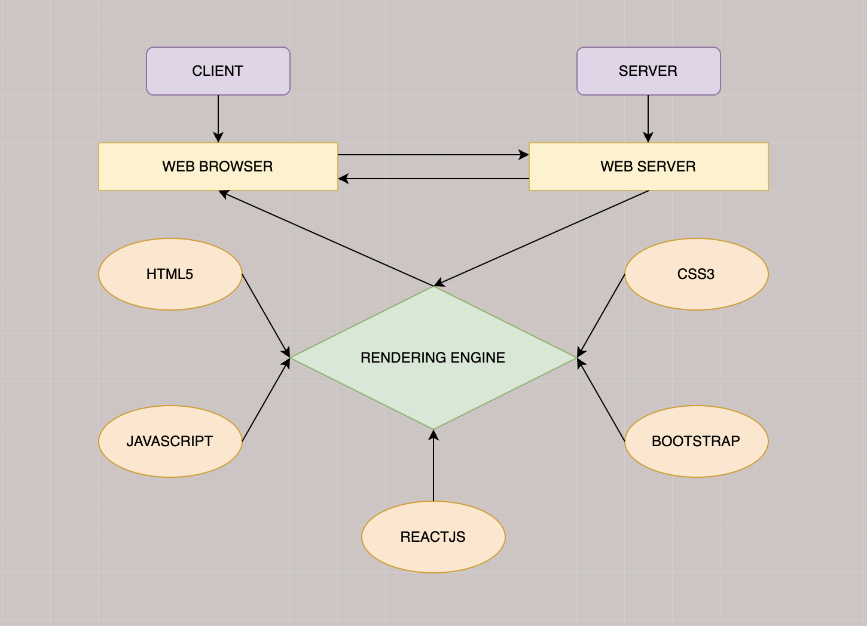

# Diagram of the website

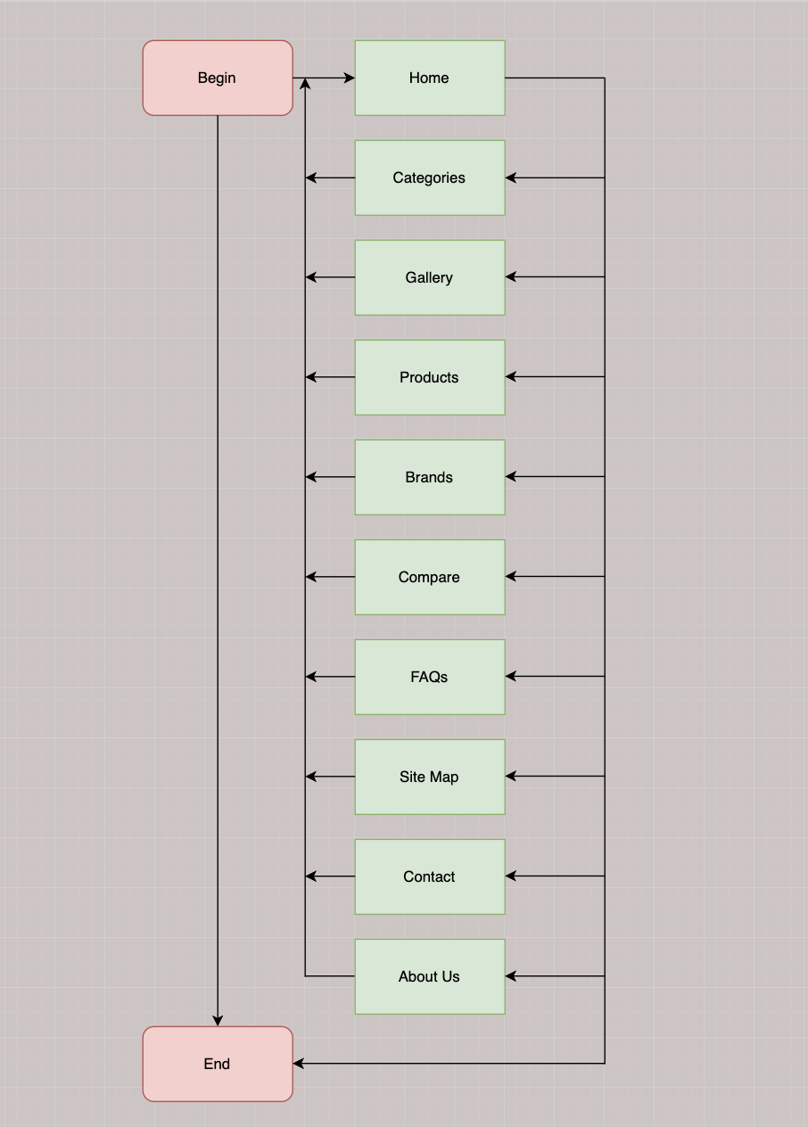



**TASK SHEET REVIEW 1**

|  |  |  |  |  |  |  |  |
| --- | --- | --- | --- | --- | --- | --- | --- |
| **Project Ref. No.:**  **eP/Advertisement Portal Management**  **System/01** | | **Project Title:** | **Activity Plan Prepared By:** | **Date of Preparation of Activity Plan:** | | | |
| **Sr.**  **No.** | **Task** | **Actual**  **Start Date** | **Actual Days** | **Team**  **Mate Names** | **Status** |
| 1 | Problem Statement | Venus Handicrafts | Han | 14-Oct-2023 | 1 | Triet,Viet, Khanh,Han | Completed |
| 2 | Analysis of the requirements about the website | 14-Oct-2023 | 1 | Triet,Viet, Khanh,Han | Completed |
| 3 | The scope of the work (in brief) | 14-Oct-2023 | 1 | Triet,Viet, Khanh,Han | Completed |
| 4 | Architecture and design of the system | 14-Oct-2023 | 1 | Triet,Viet, Khanh,Han | Completed |
| 5 | Diagram of the website | 14-Oct-2023 | 1 | Triet,Viet, Khanh,Han | Completed |
| 6 | Task Sheet | 14-Oct-2023 | 1 | Triet,Viet, Khanh,Han | Completed |

|  |  |
| --- | --- |
| **Date: 21/10/2023** | |
| Signature of Instructor:  **Mr. Nguyen Phat Tai** | Signature of Team Leader:    **Ms.Le Thi Ngoc Han** |

# SITE MAP

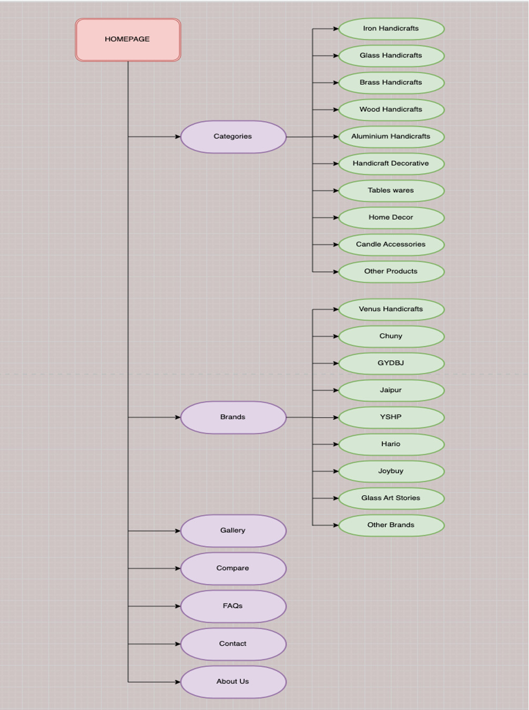

# MOCK OF THE WEBSITE

* + - 1. **HOMEPAGE**

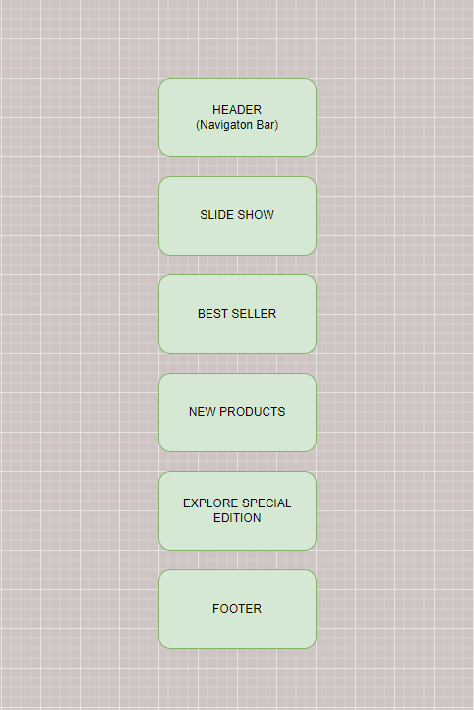

* + - 1. **PRODUCT**

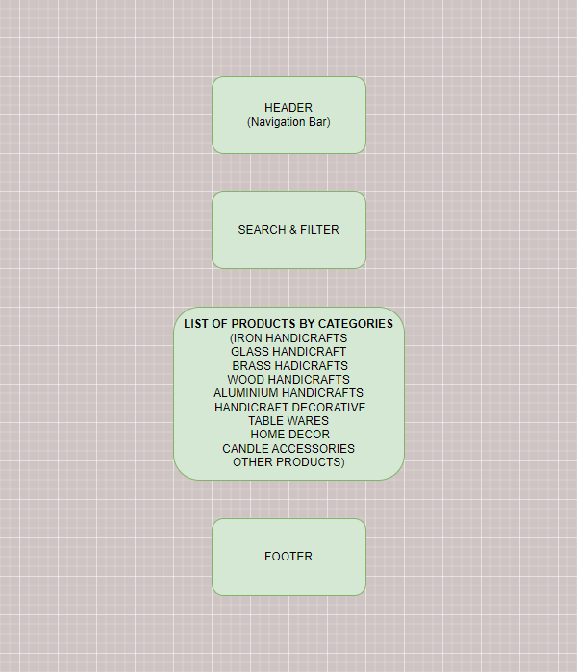

* + - 1. **BRAND**

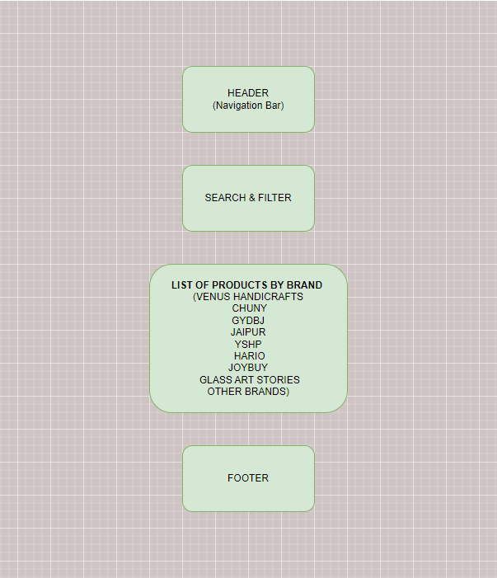

* + - 1. **GALLERY**

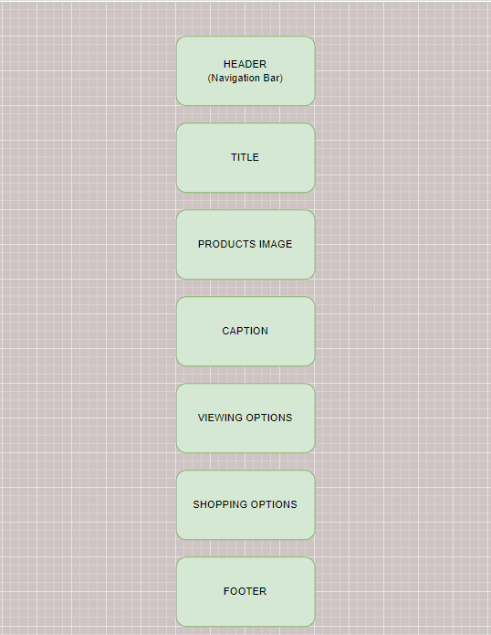

* + - 1. **FAQs**

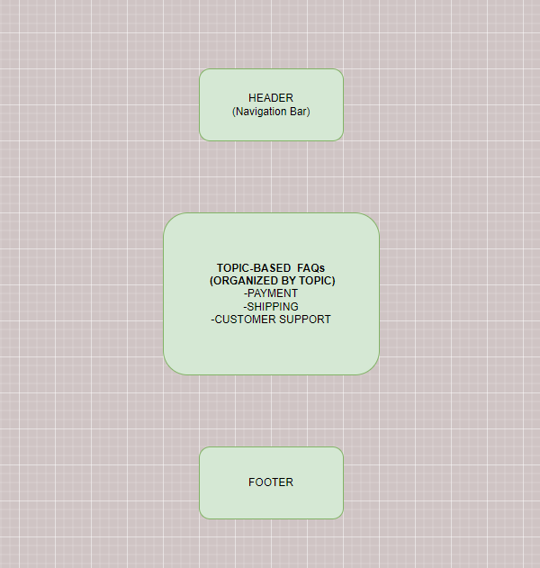

* + - 1. **COMPARE**

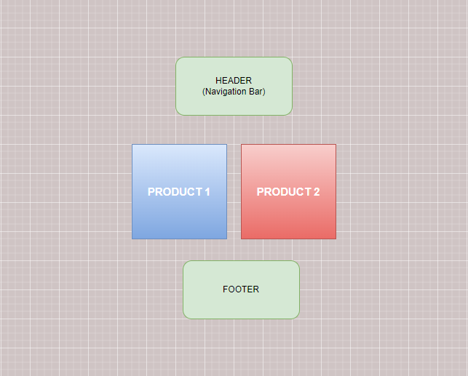

* + - 1. **CONTACT US**

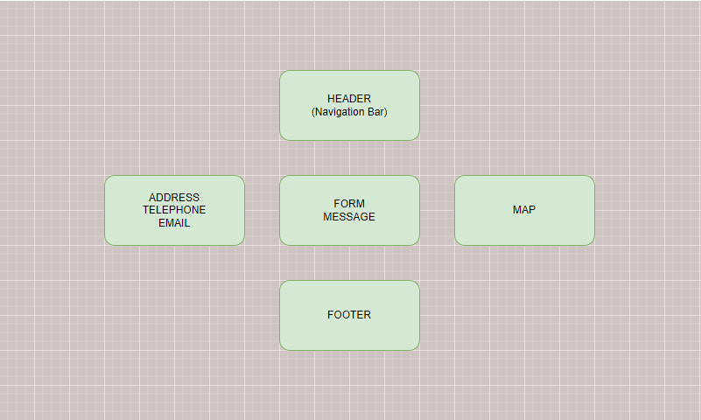

* + - 1. **ABOUT US**

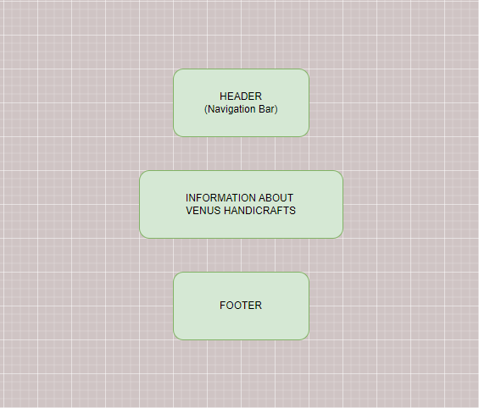

# TASK SHEET REVIEW 2

|  |  |  |  |  |  |  |  |
| --- | --- | --- | --- | --- | --- | --- | --- |
| **Project Ref. No.:**  **eP/Advertisement**  **Portal Management System/01** | | **Project Title:** | **Activity Plan Prepared By:** | **Date of Preparation of Activity Plan:** | | | |
| **Sr.**  **No.** | **Task** | **Actual**  **Start Date** | **Actual Days** | **Team**  **Mate Names** | **Status** |
| 1 | Site map | Venus Handicrafts | Han | 26-Oct-2023 | 1 | Triet,Viet, Khanh,Han | Completed |
| 2 | Mock of the website | 26-Oct-2023 | 1 | Triet,Viet, Khanh,Han | Completed |
| 3 | Task Sheet | 26-Oct-2023 | 1 | Triet,Viet, Khanh,Han | Completed |

|  |  |
| --- | --- |
| **Date: 26/10/2023** | |
| Signature of Instructor:  **Mr. Nguyen Phat Tai** | Signature of Team Leader:  **Ms. Le Thi Ngoc Han** |

# WEBSITE DESCRIPTION

1. **Home Page:**

* Screenshot

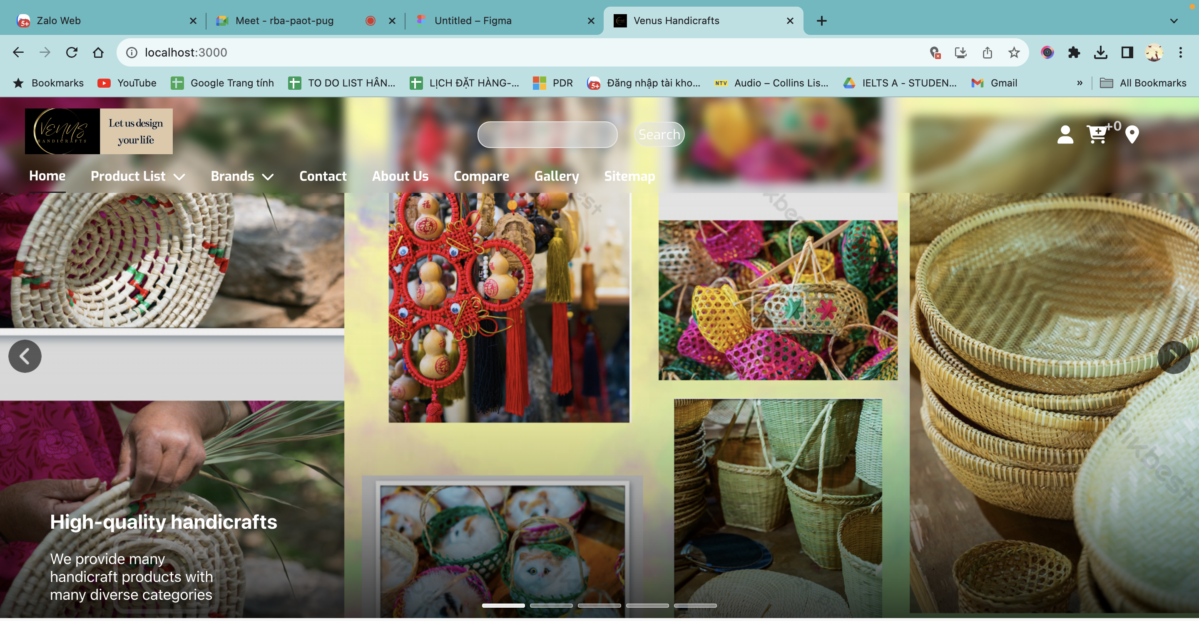

**Figure 1.1:** Homepage slideshow

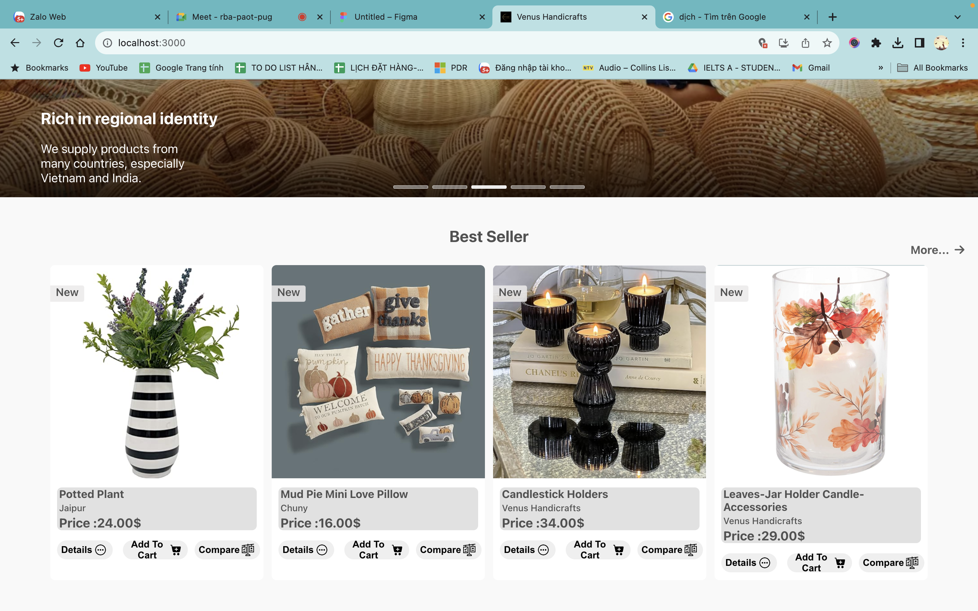

**Figure 1.2:** Best Seller

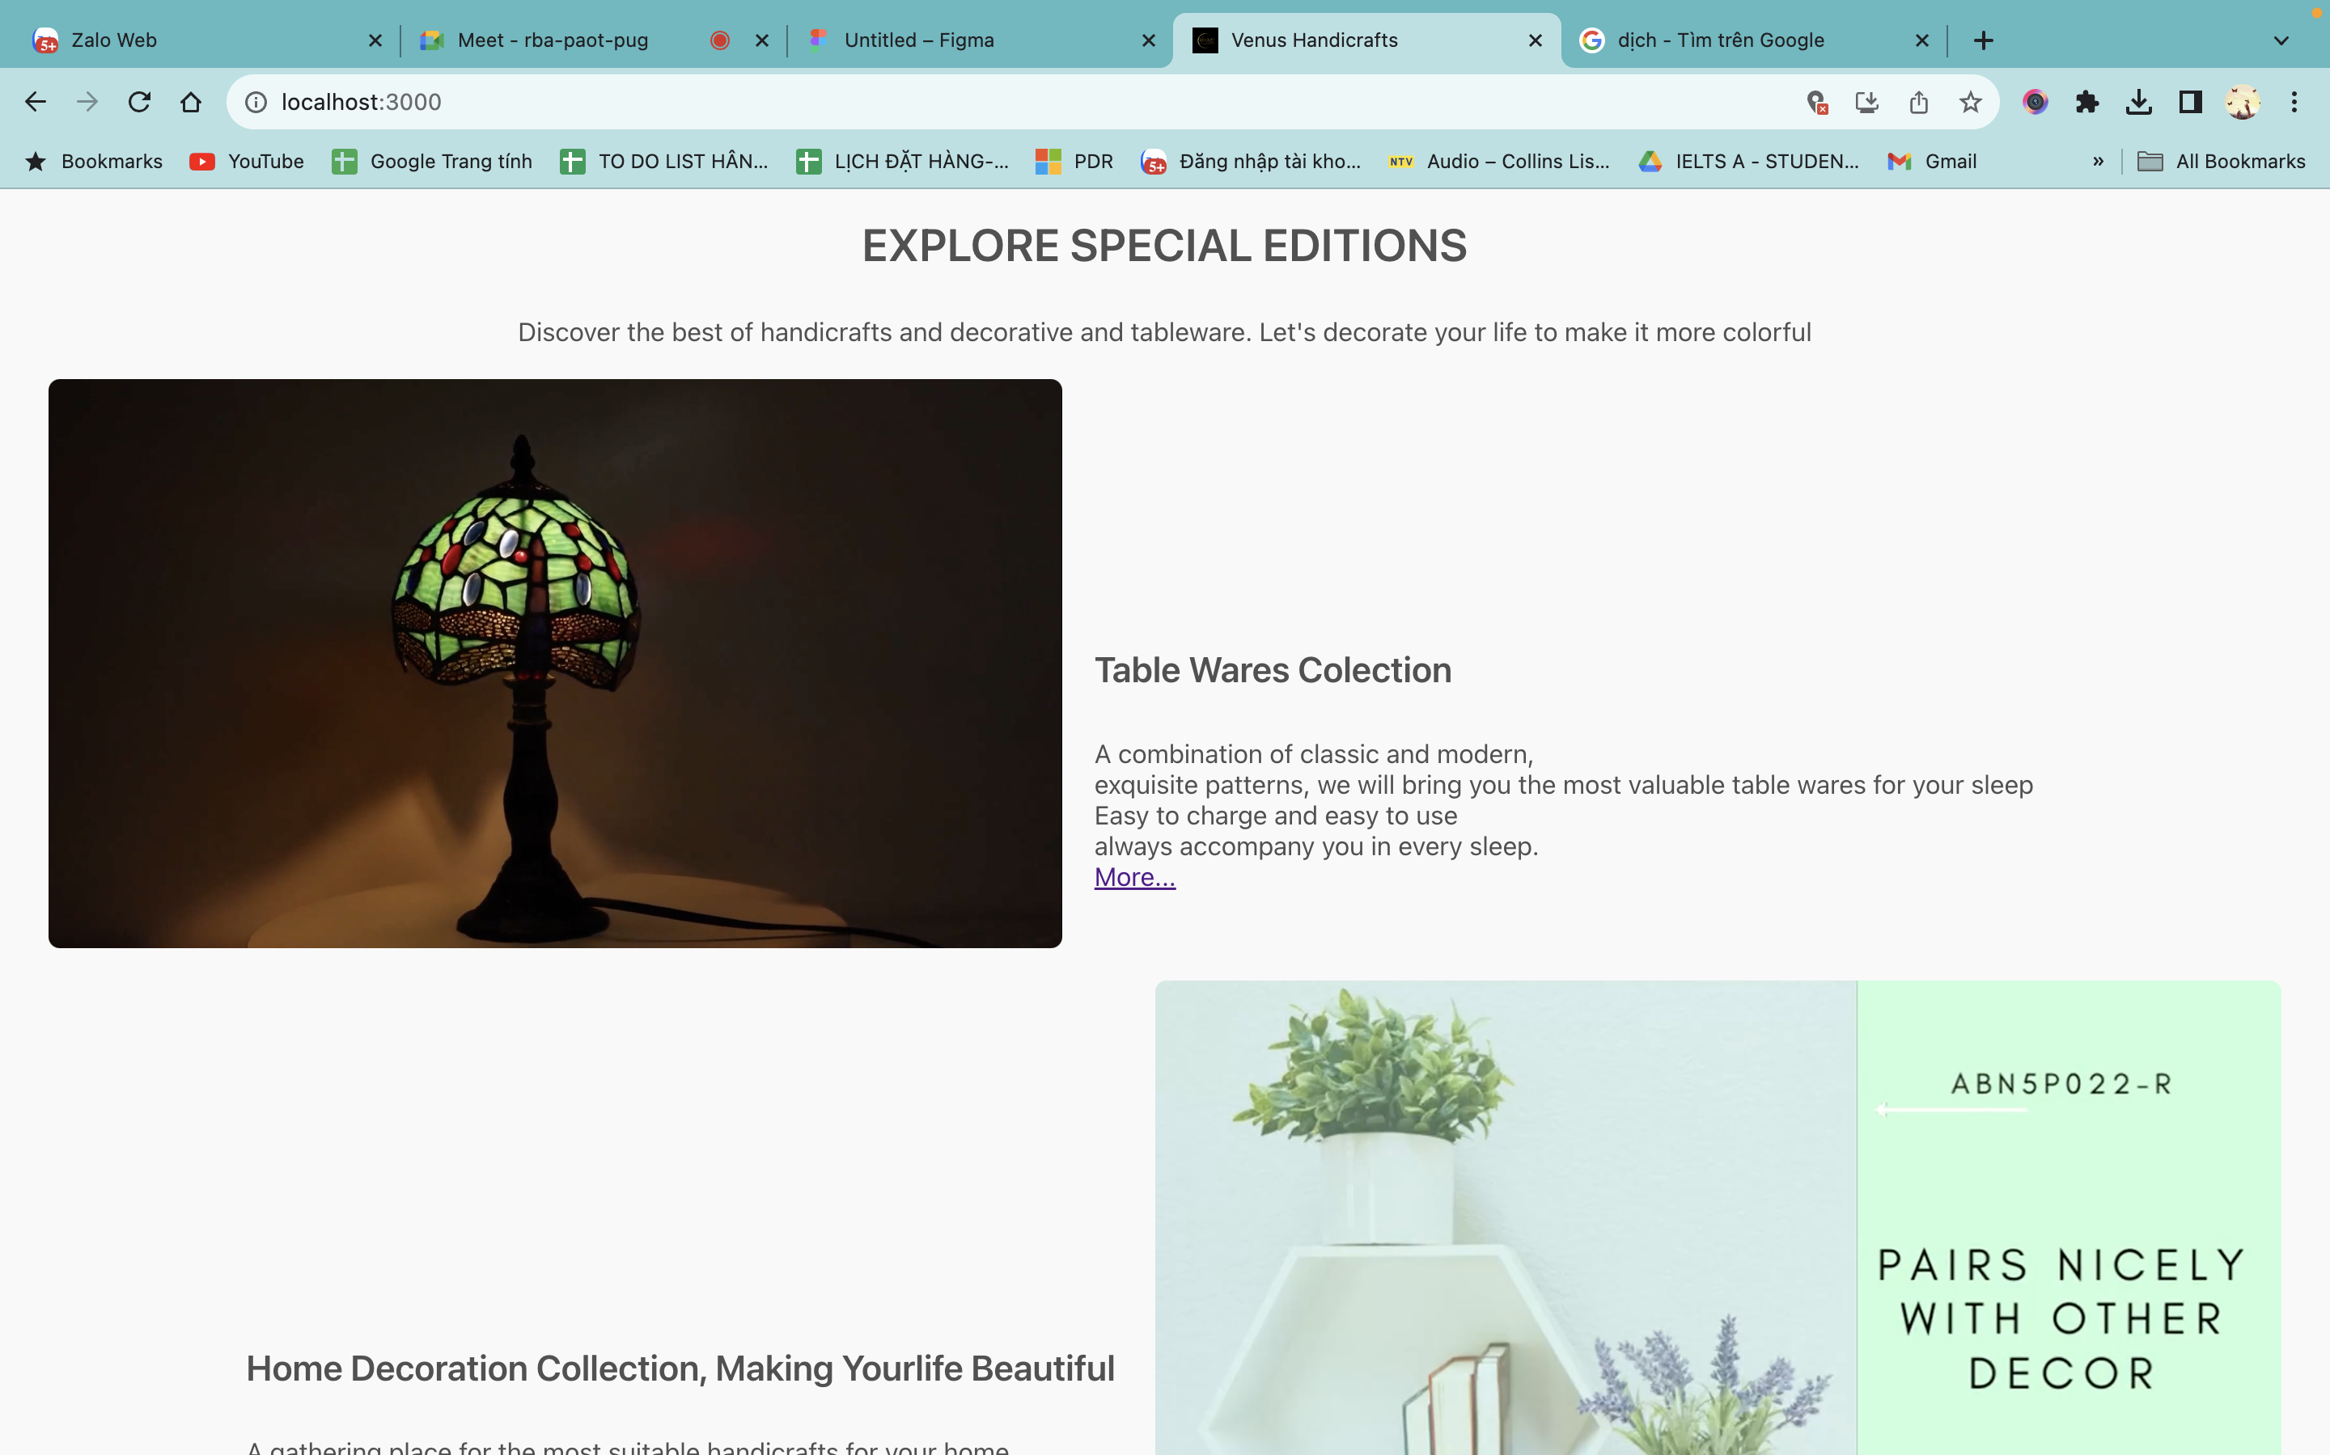

**Figure 1.3:** Explore Special Edition

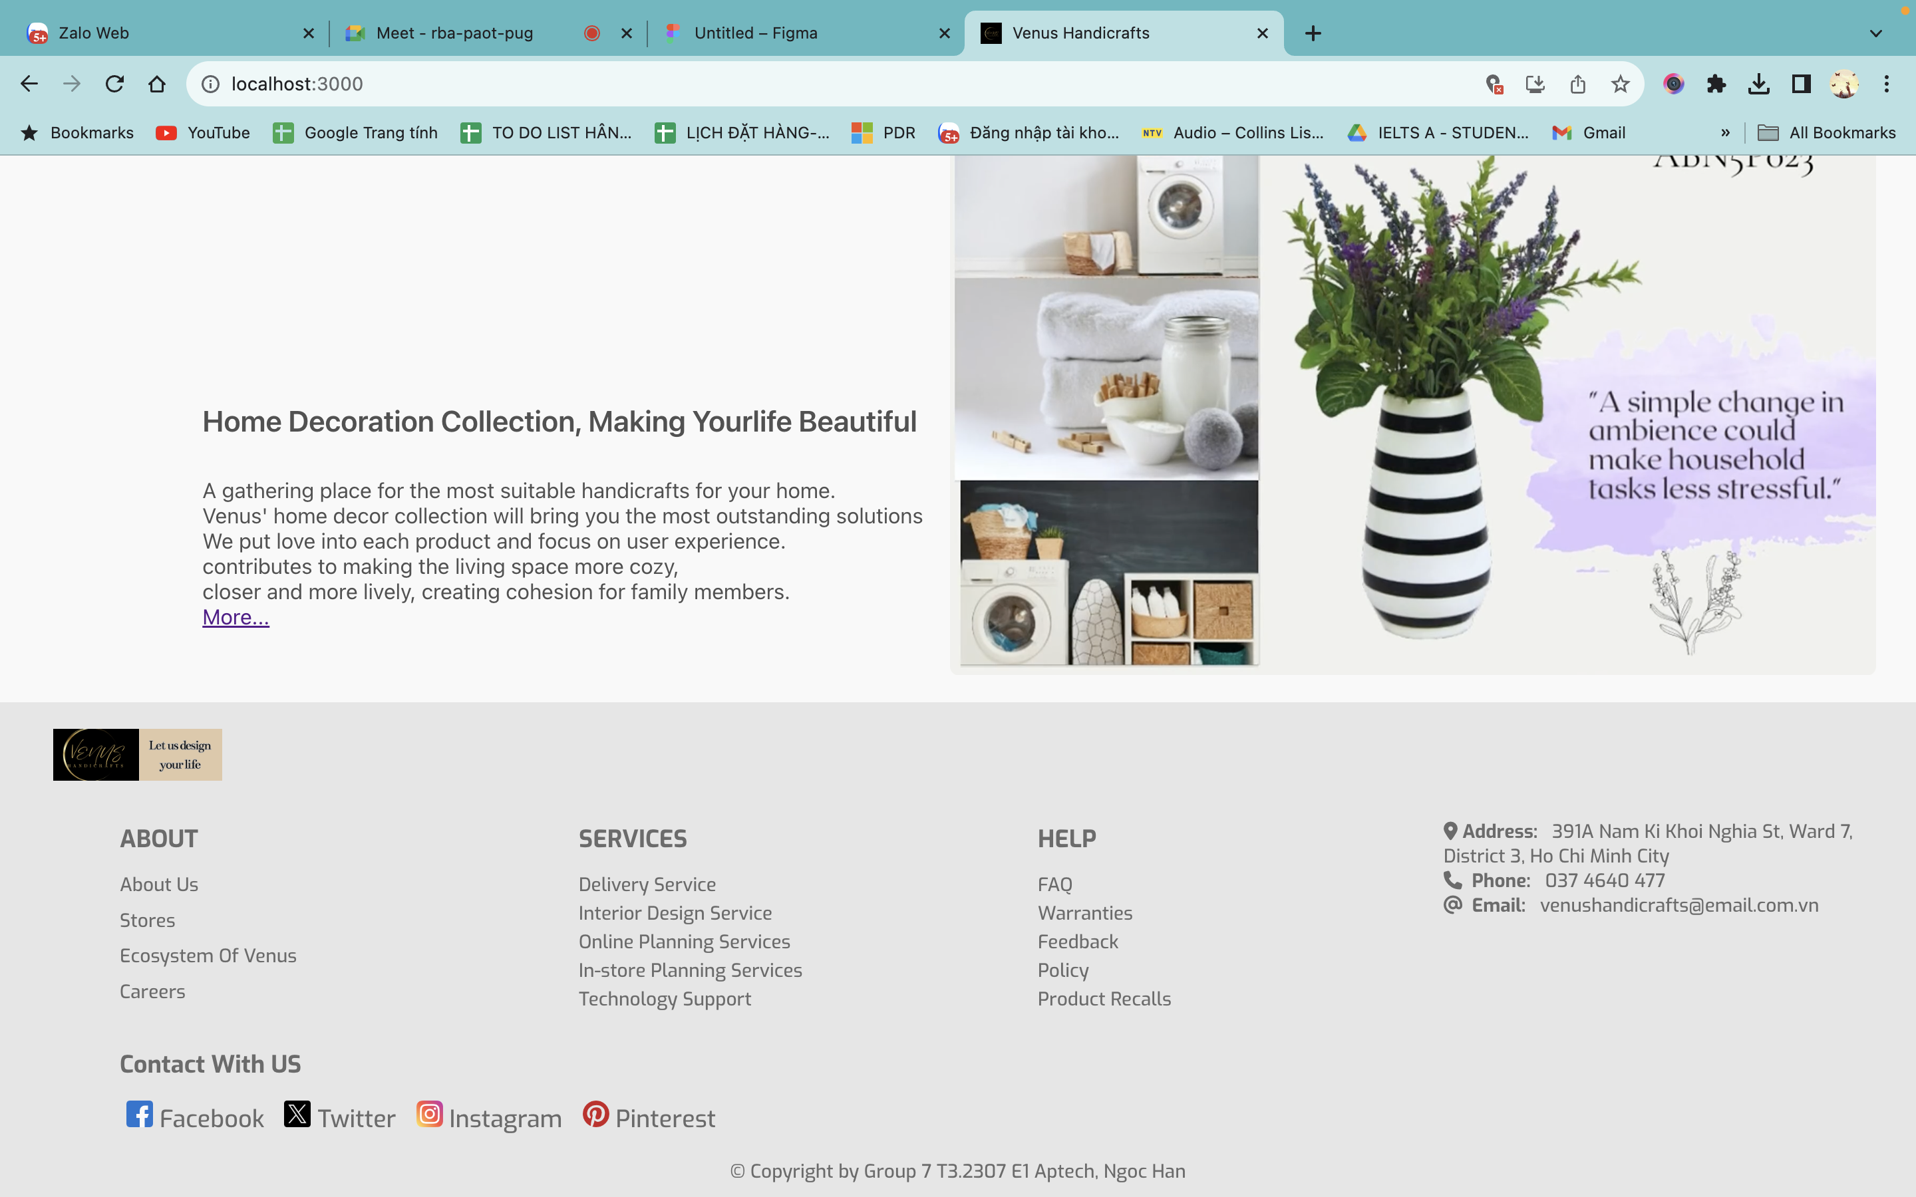

**Figure 1.4:** Footer

1. **MenuDropdown1**

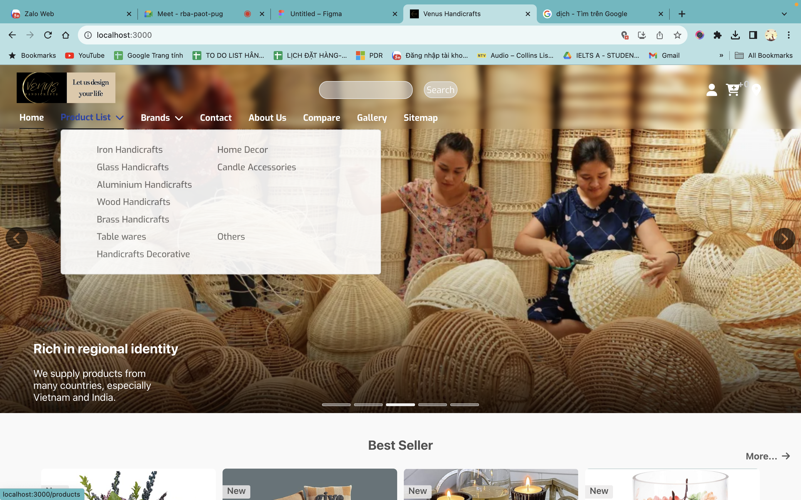

1. **MenuDropDown2**

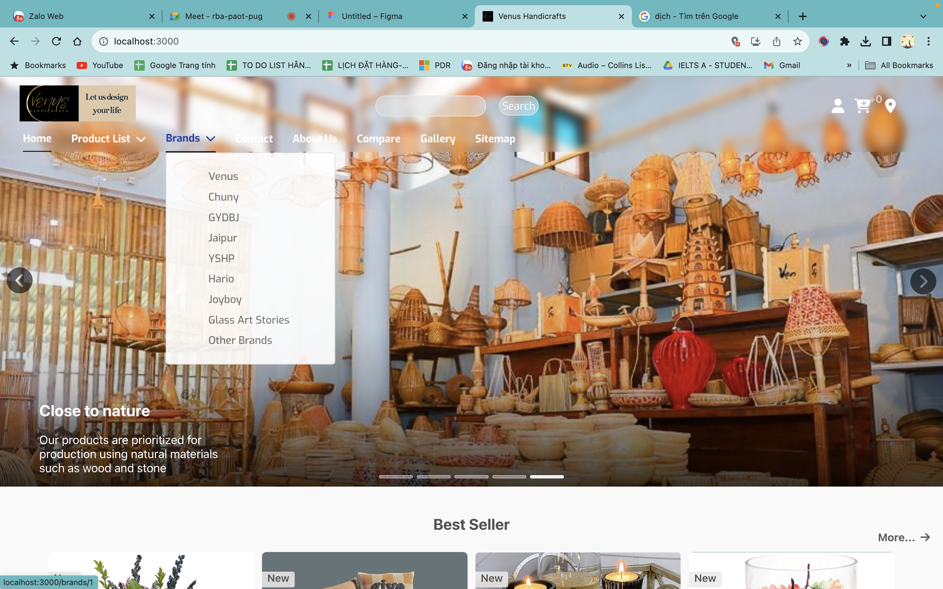

1. **ProductsPage**

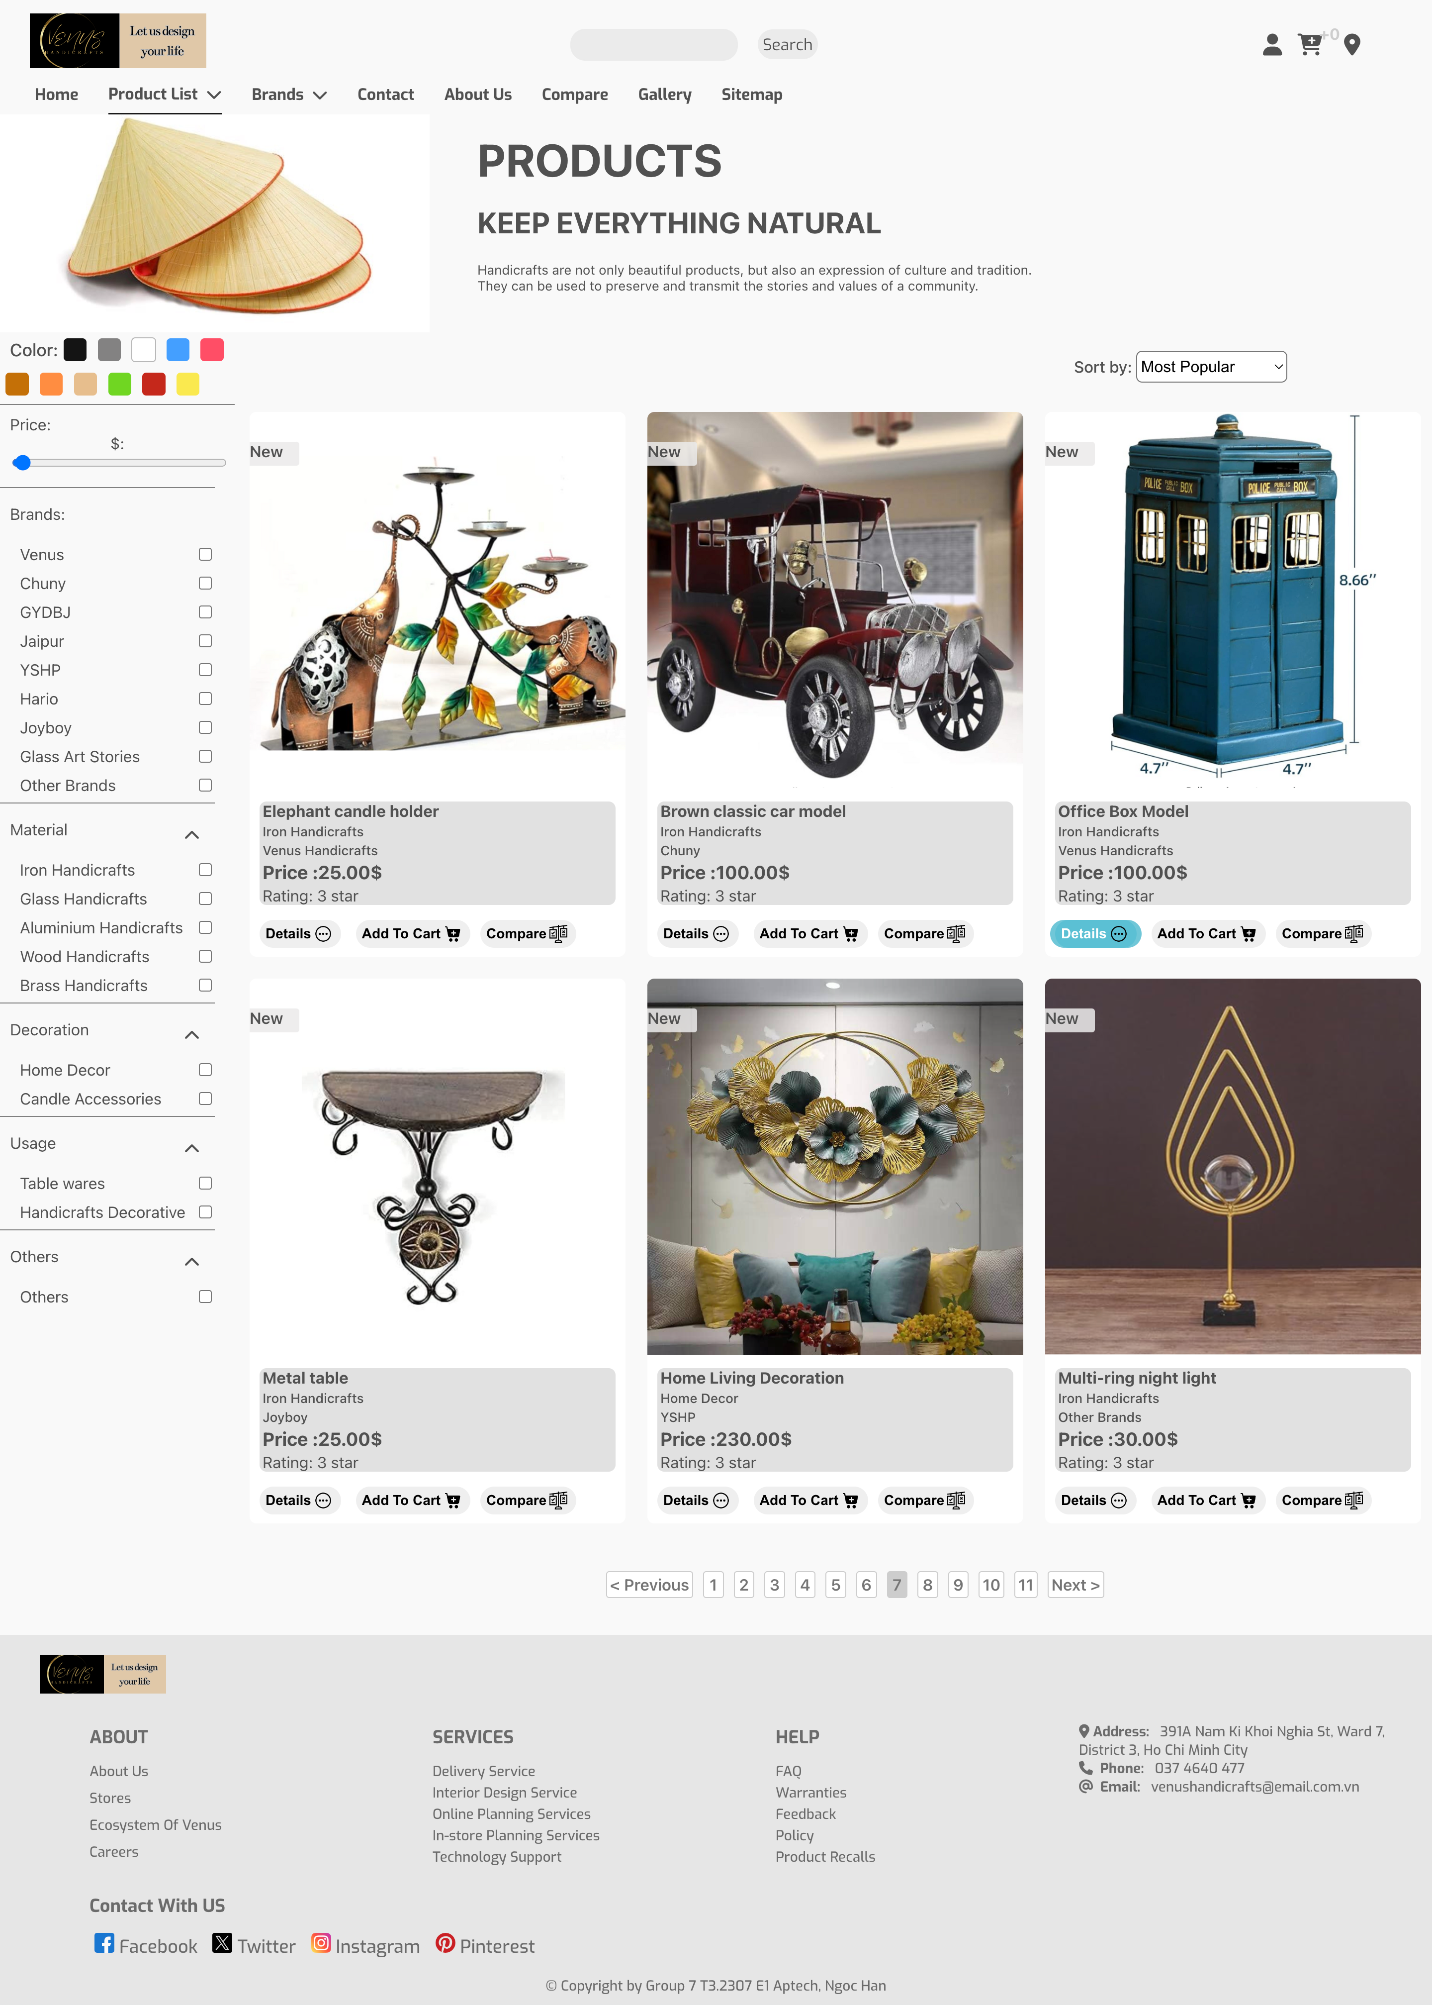

## BrandsPage

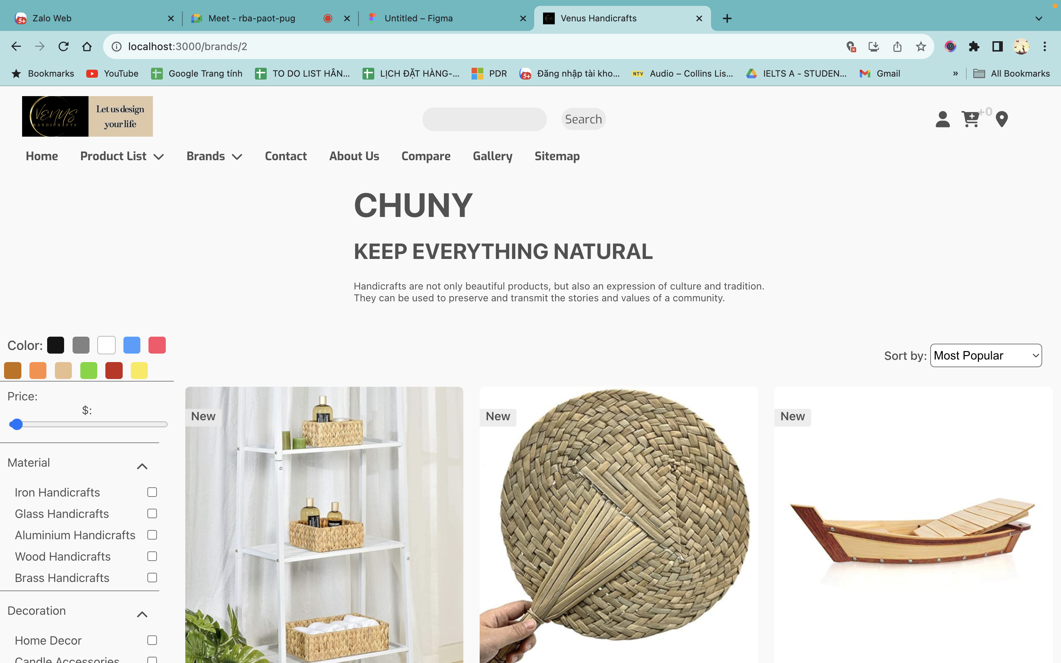

## ProductDetail

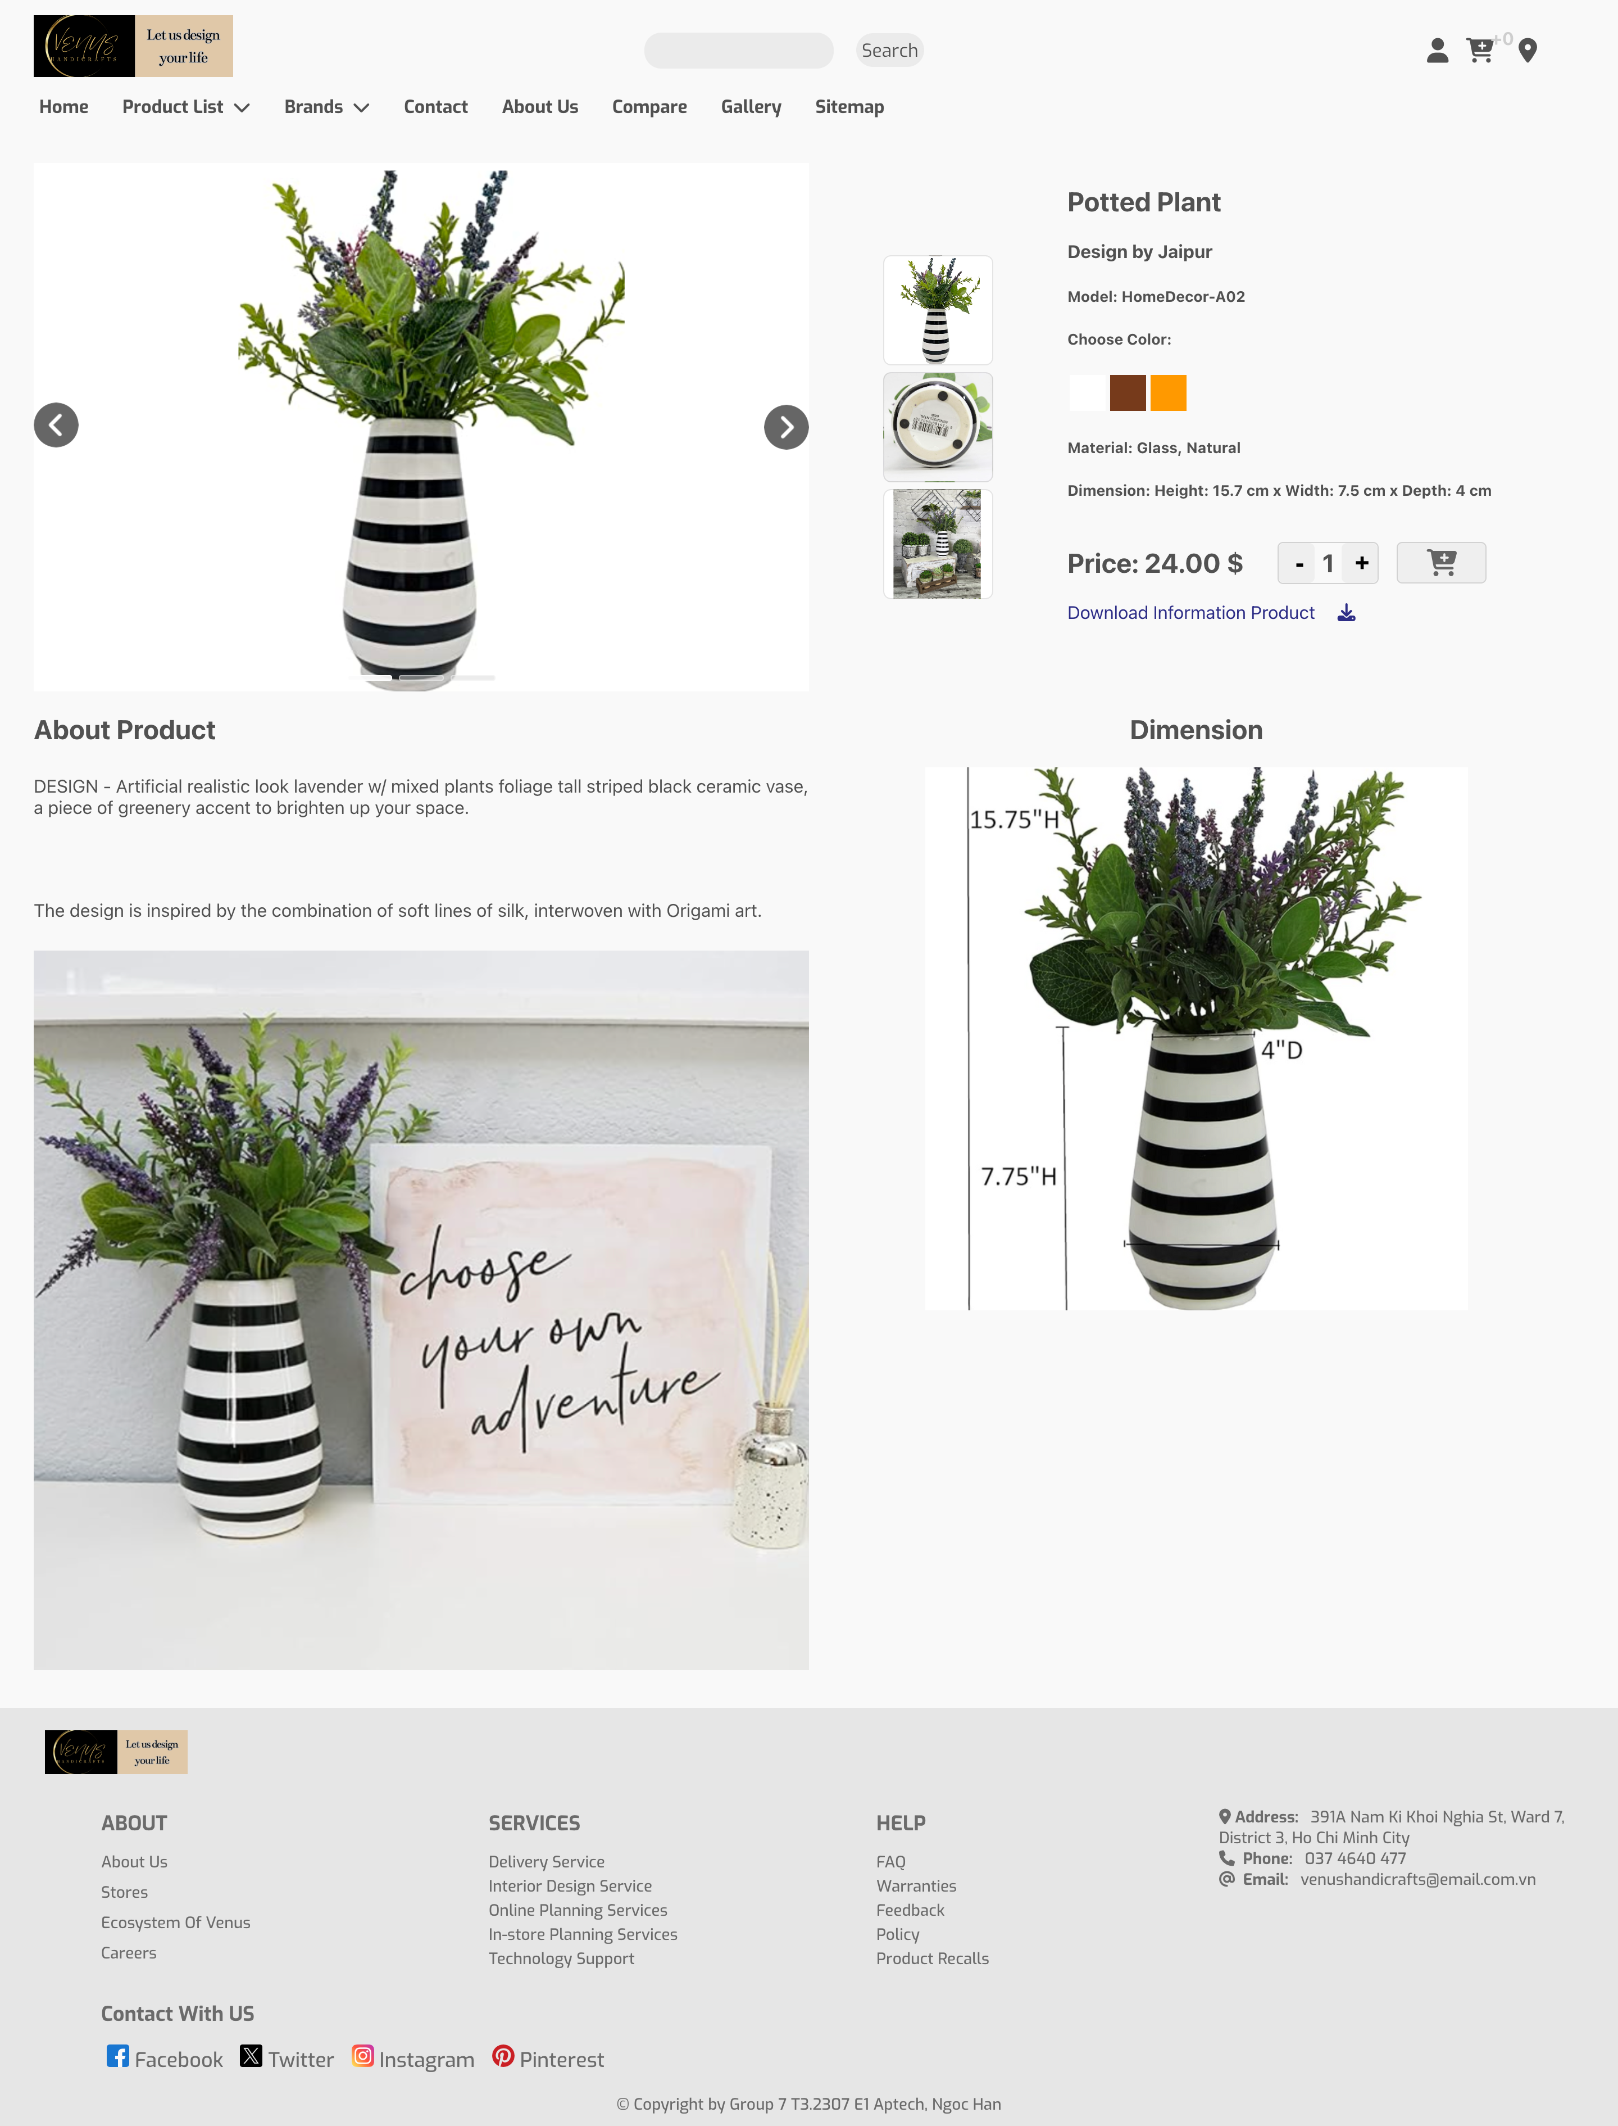

## Compare

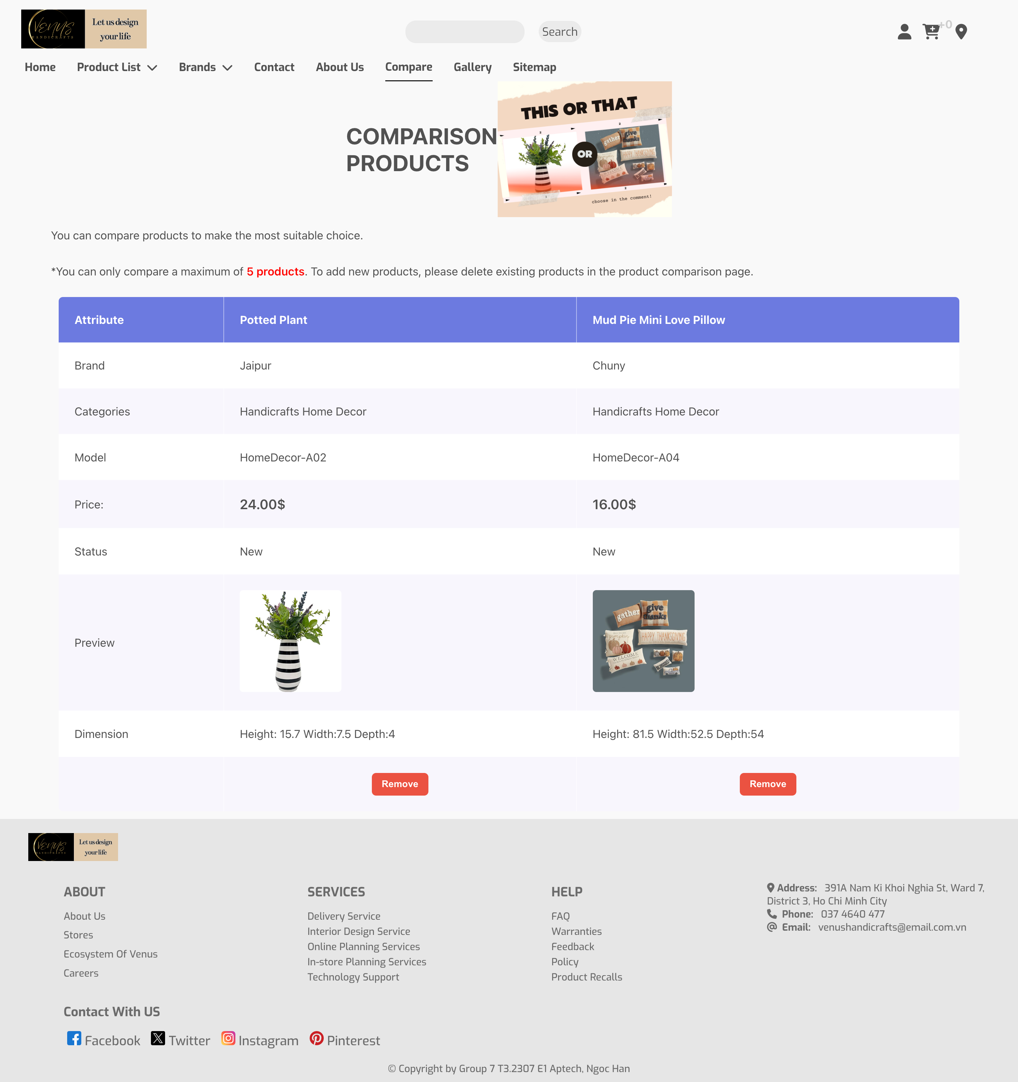

1. **Sitemap**

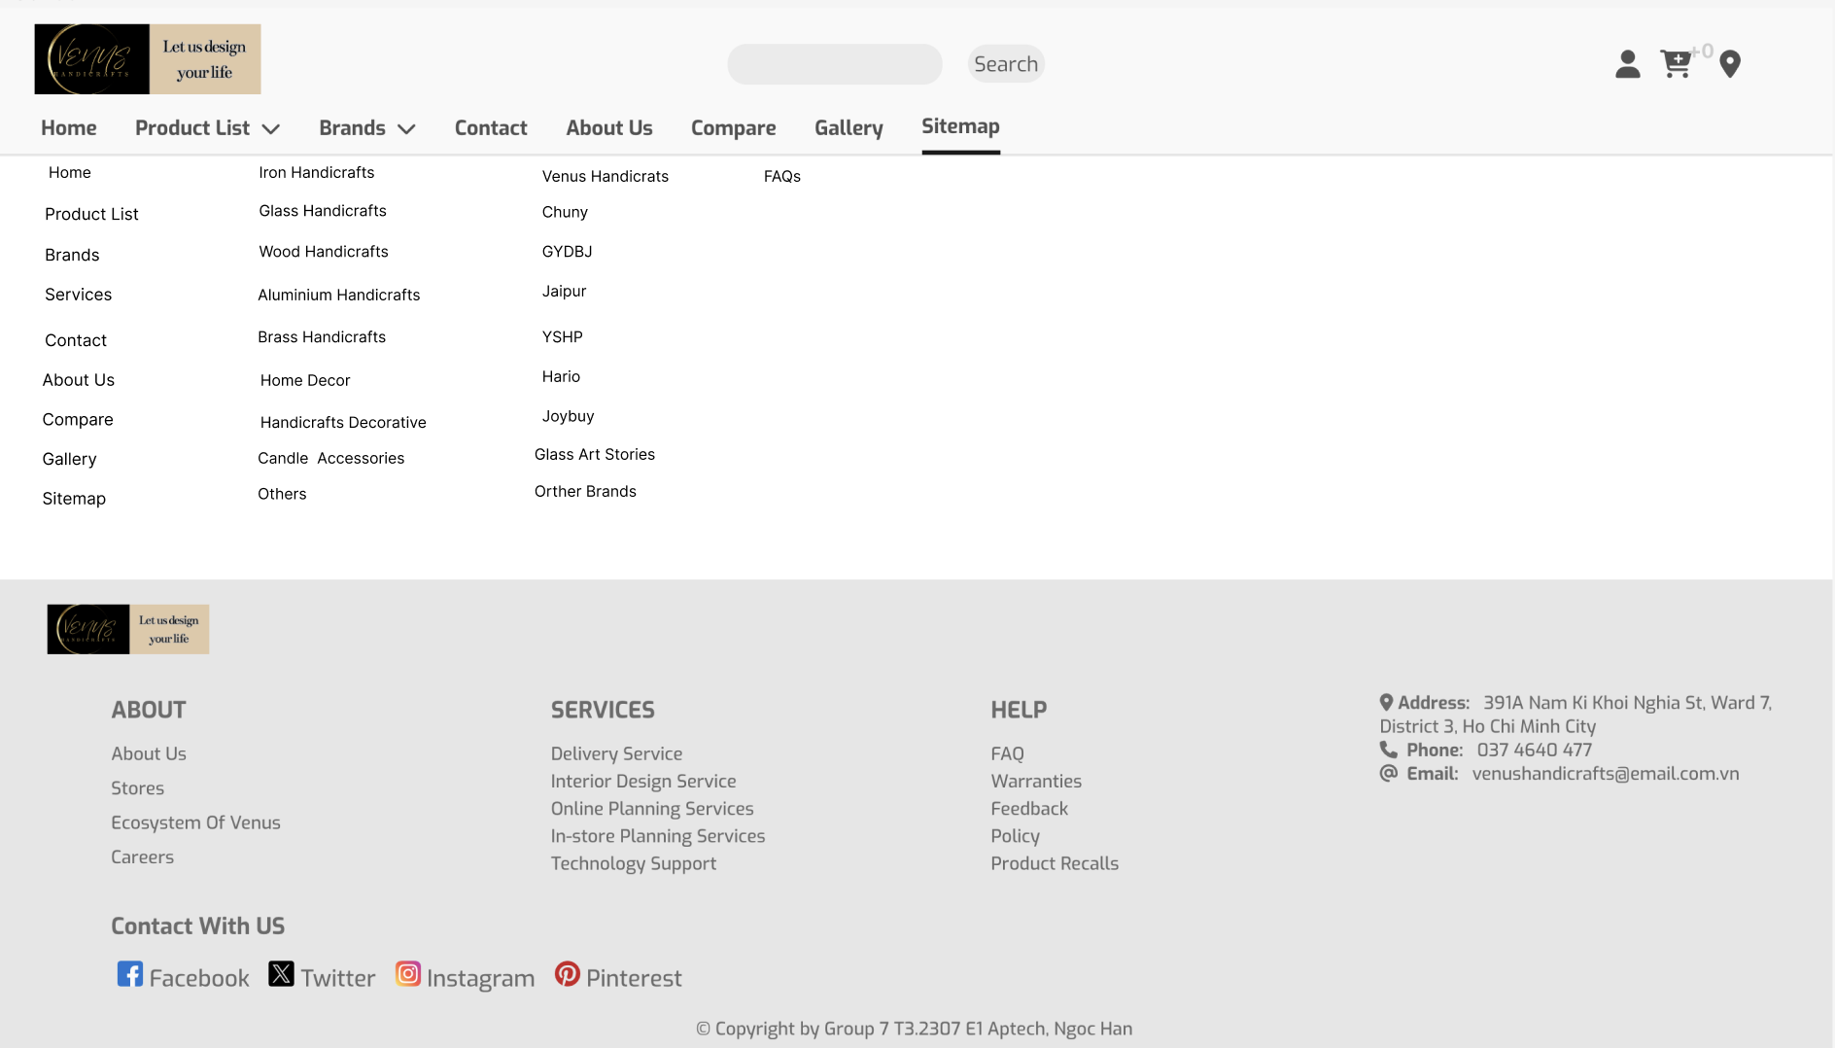

1. **FAQs**

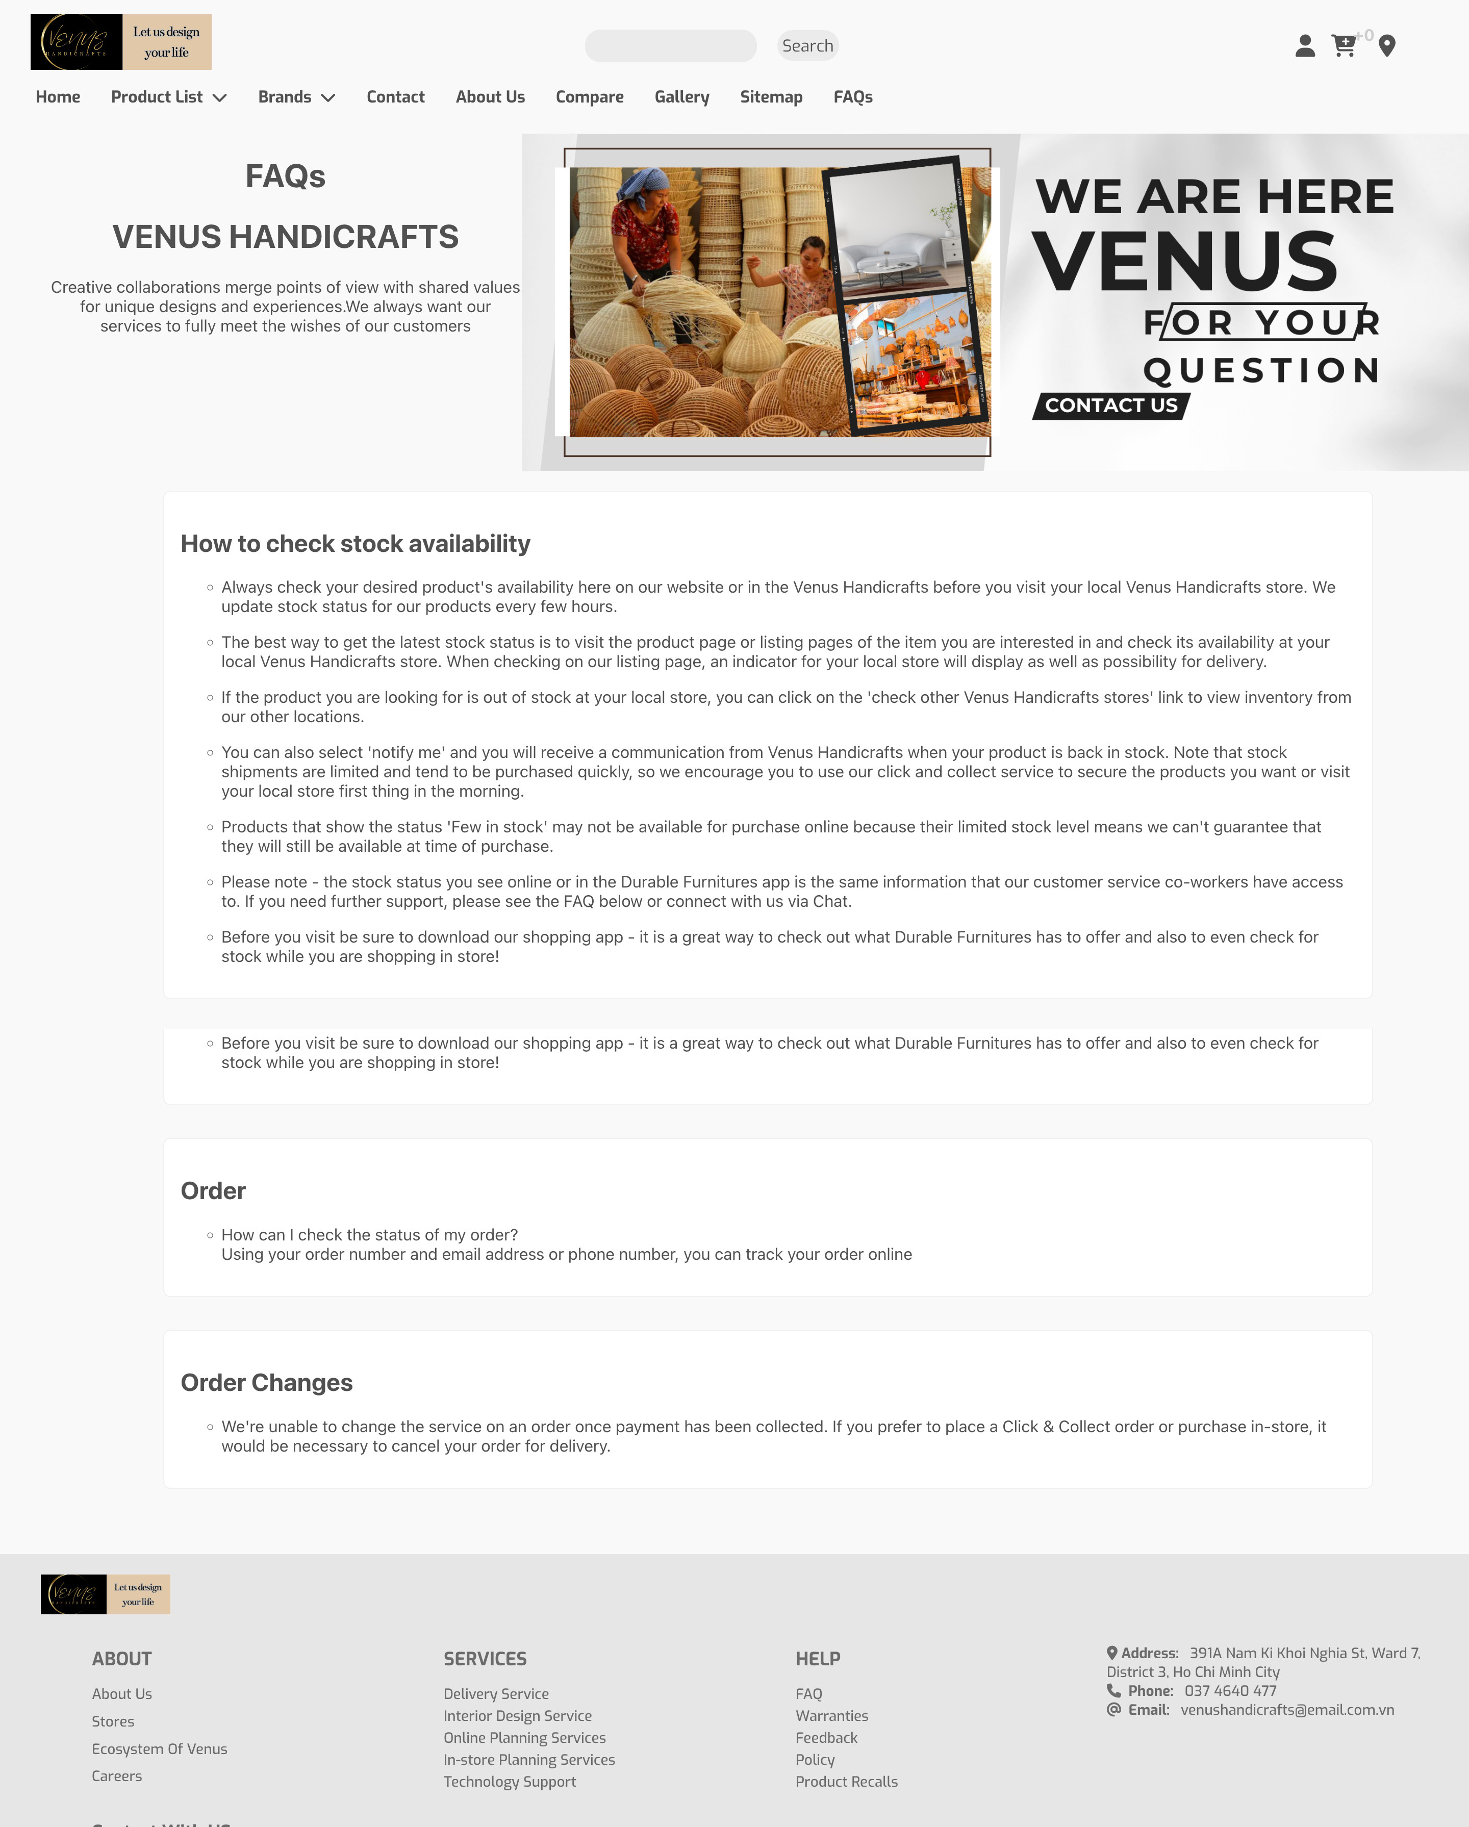

1. AboutUsPage

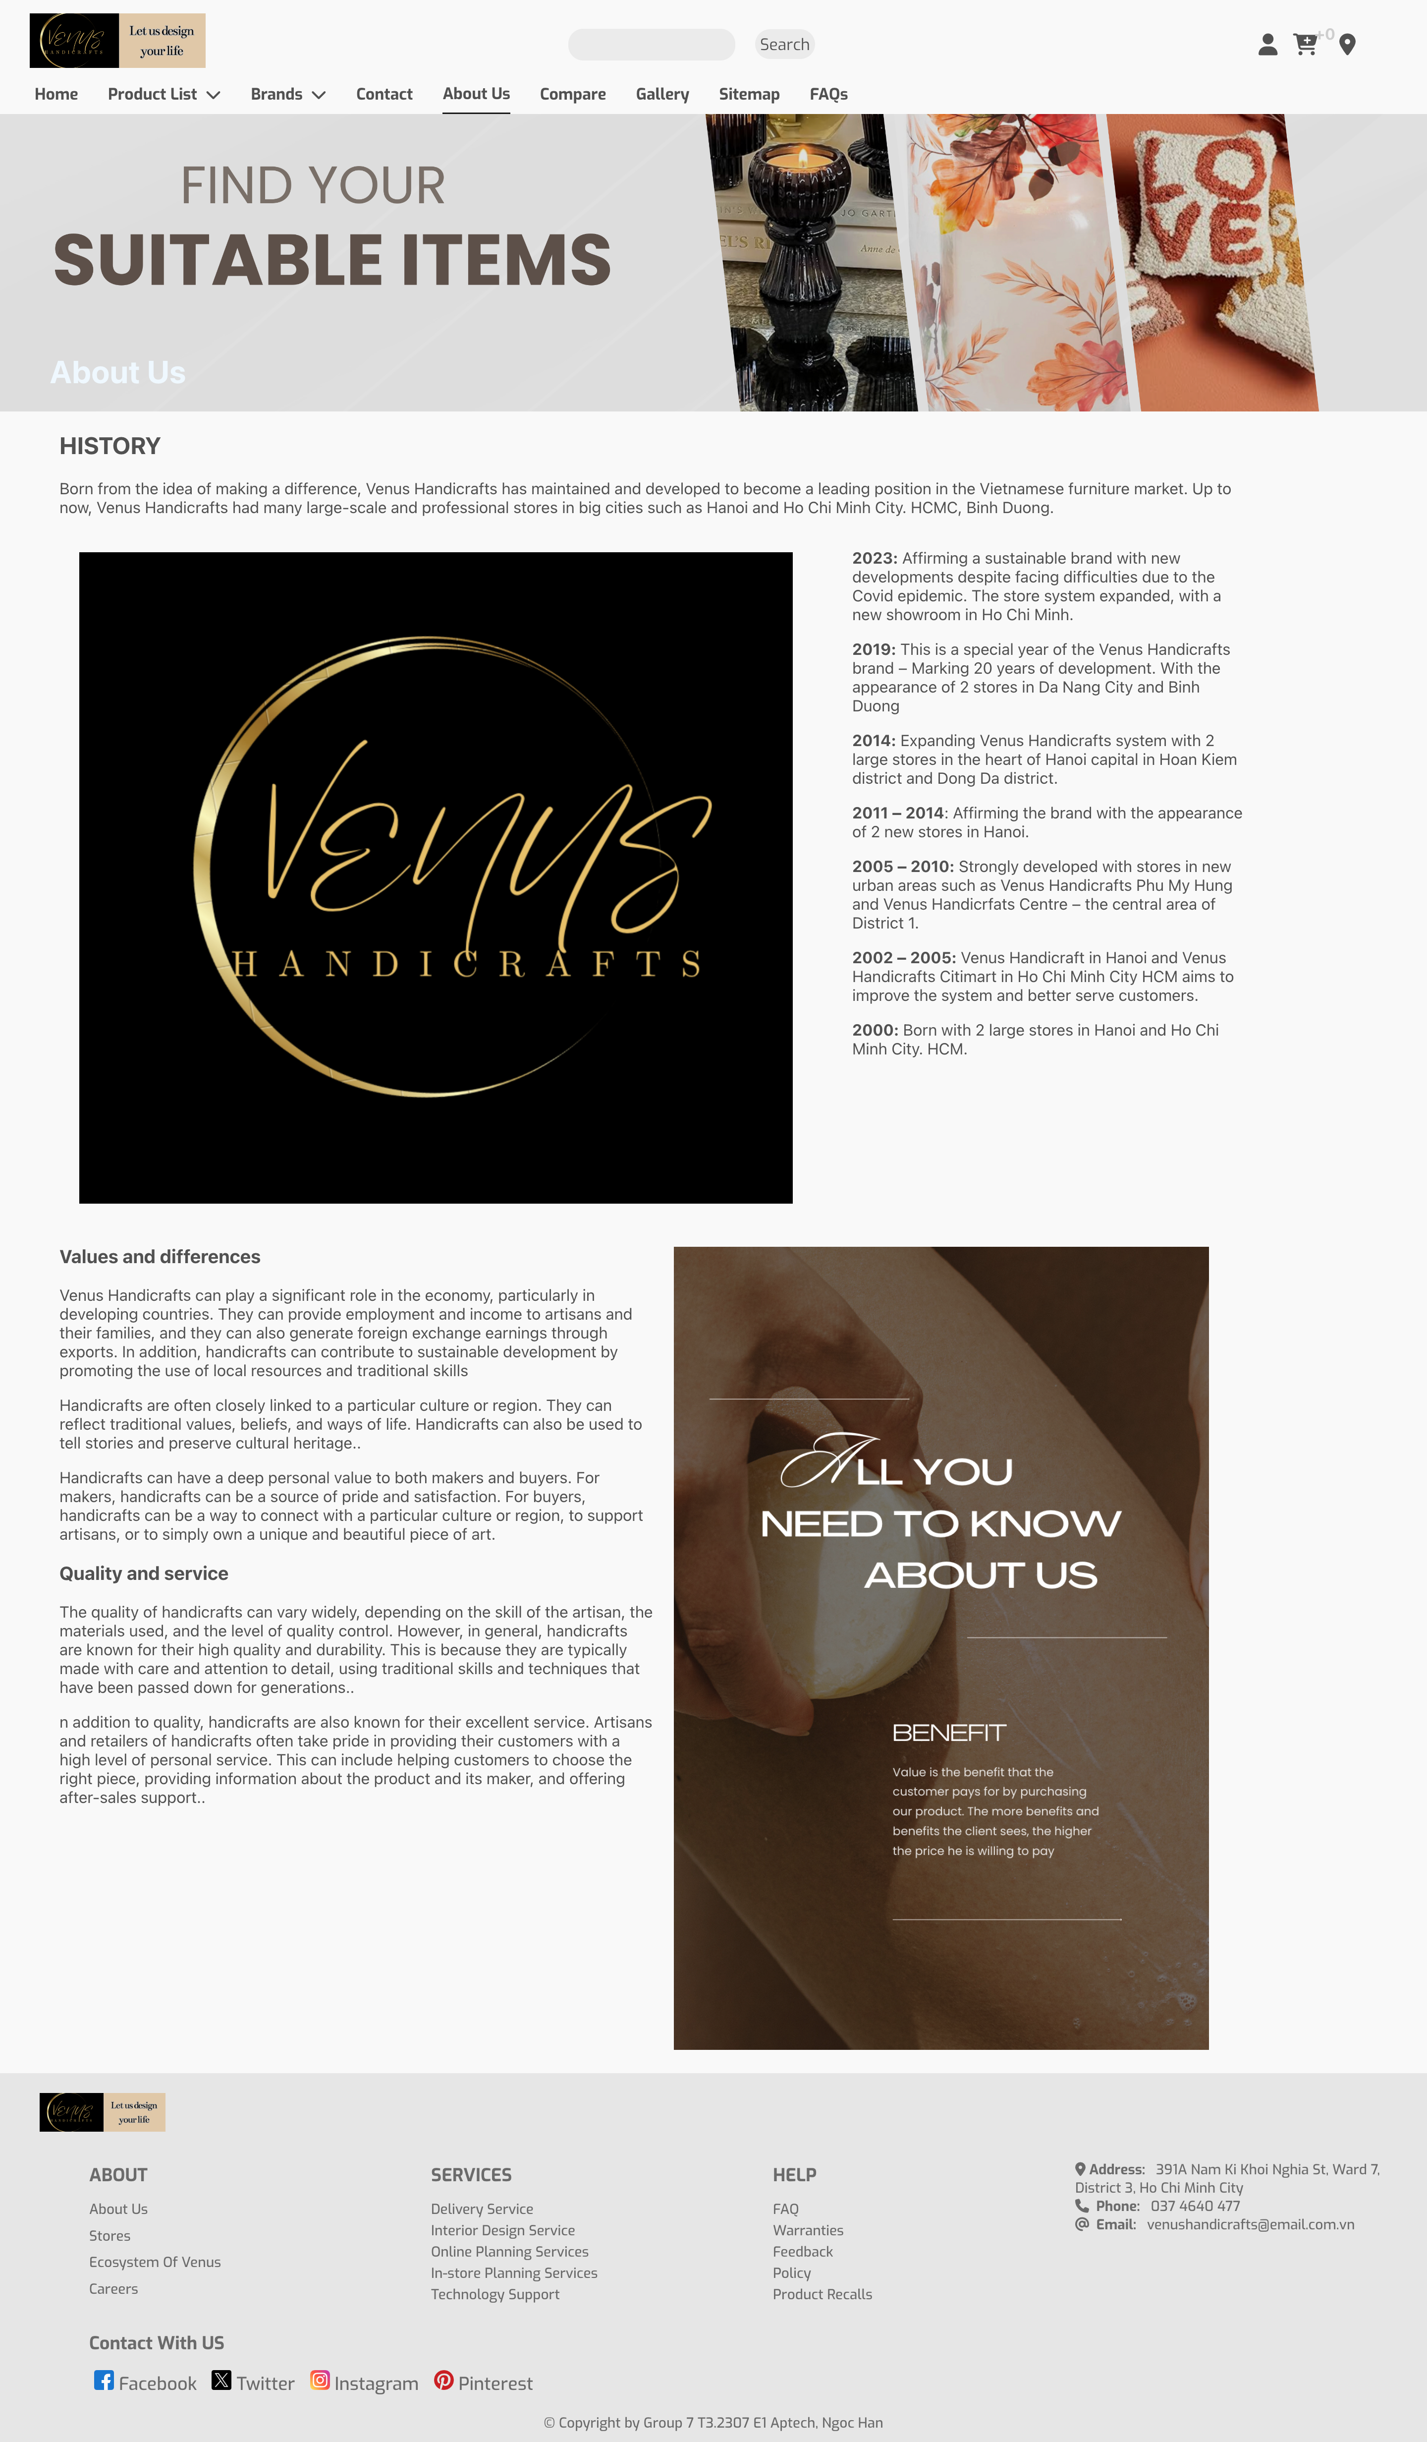

## ContactPage

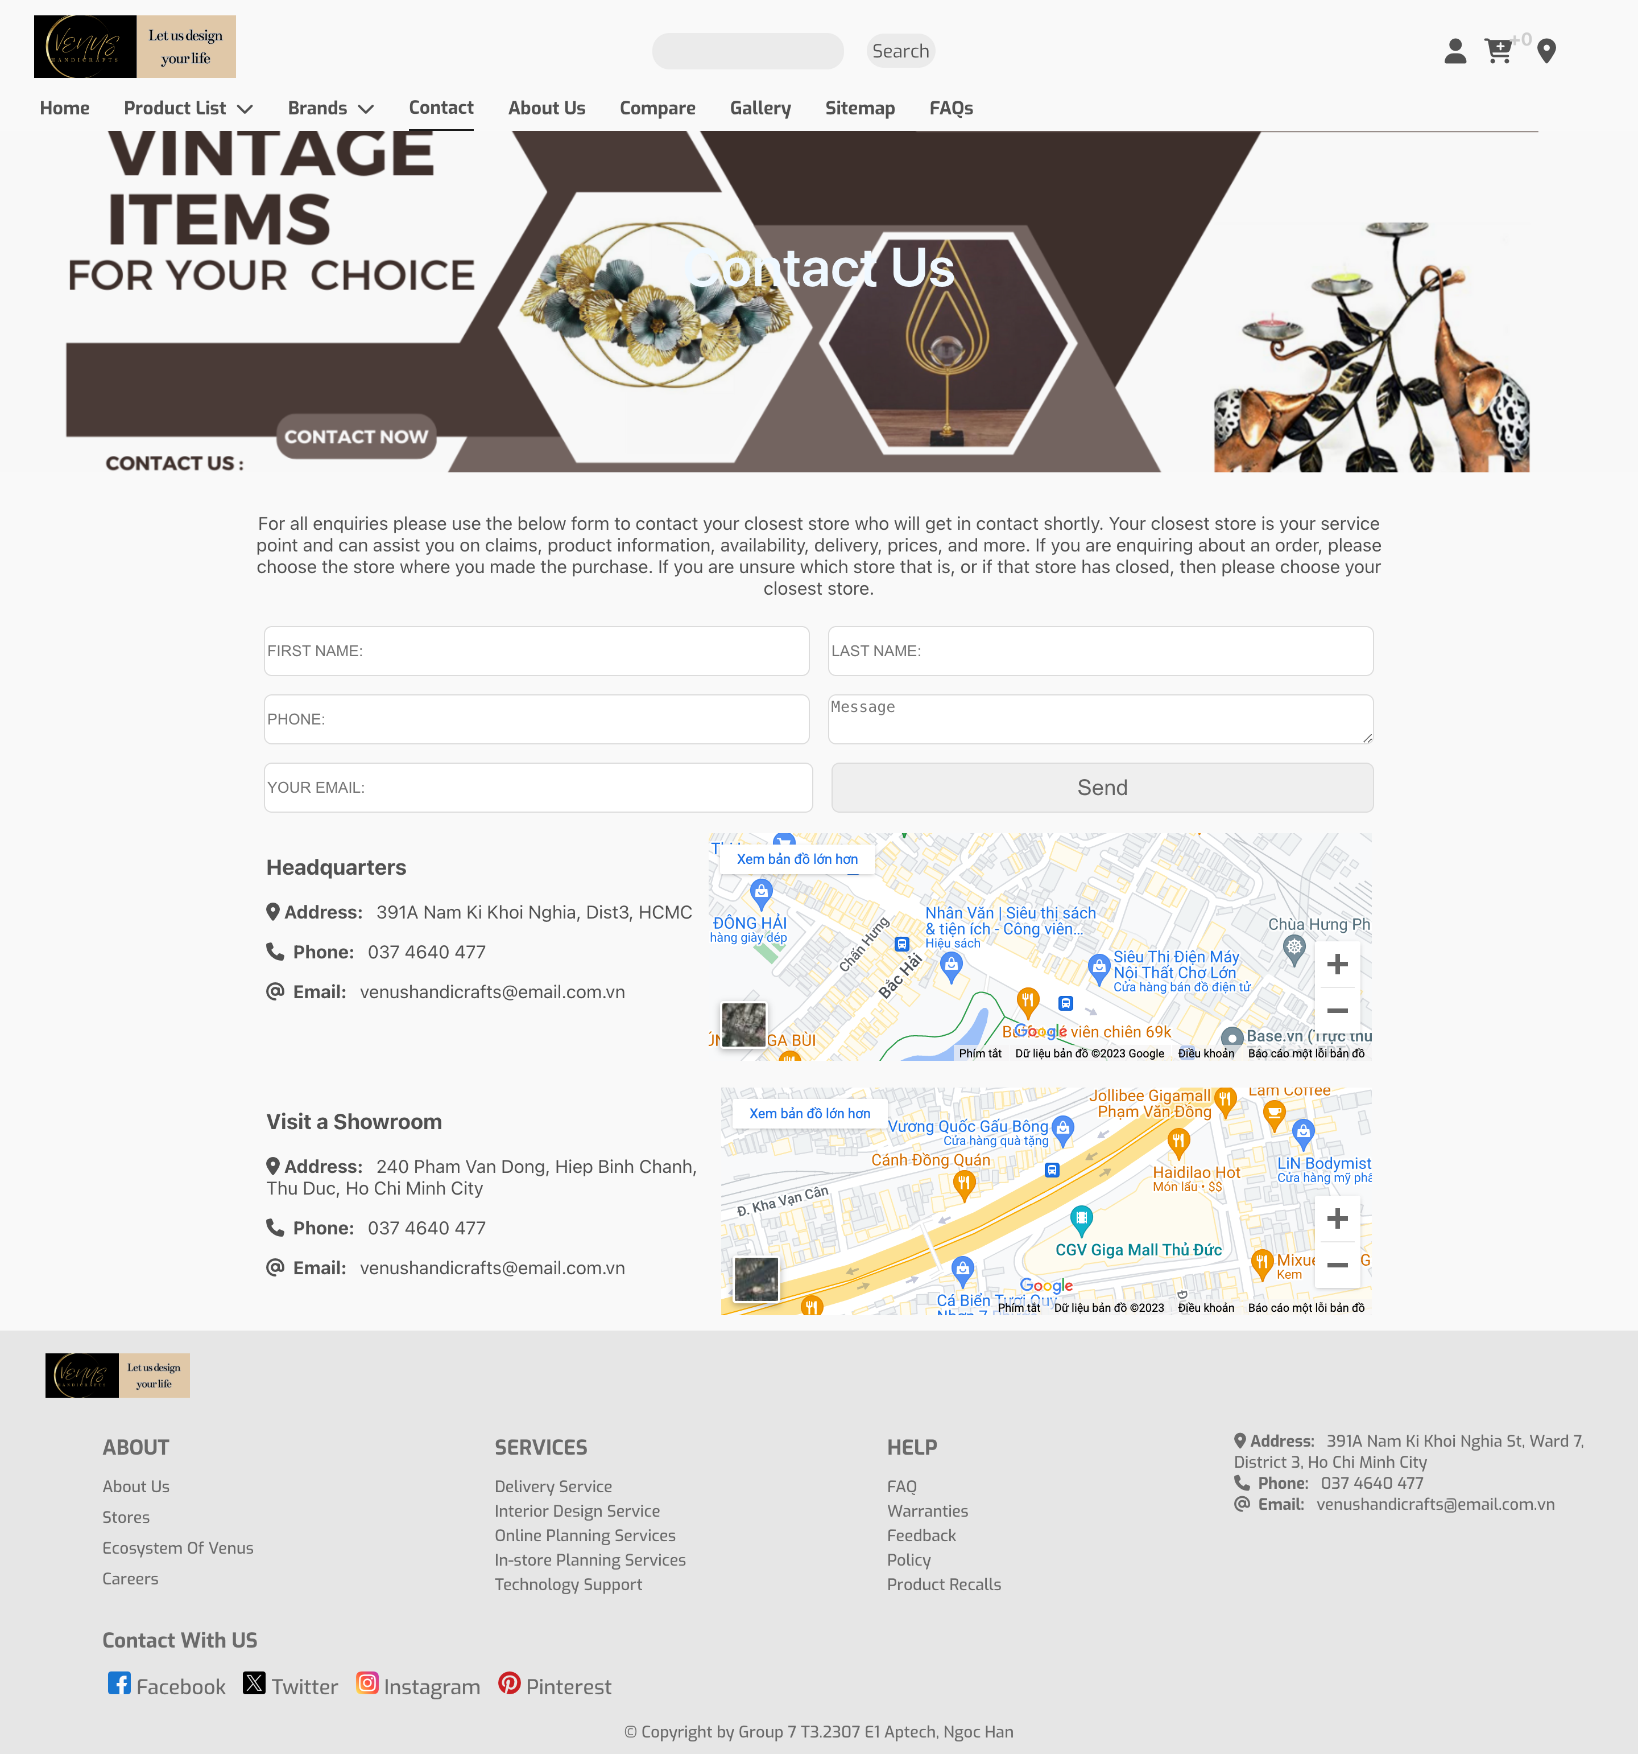

## Gallery

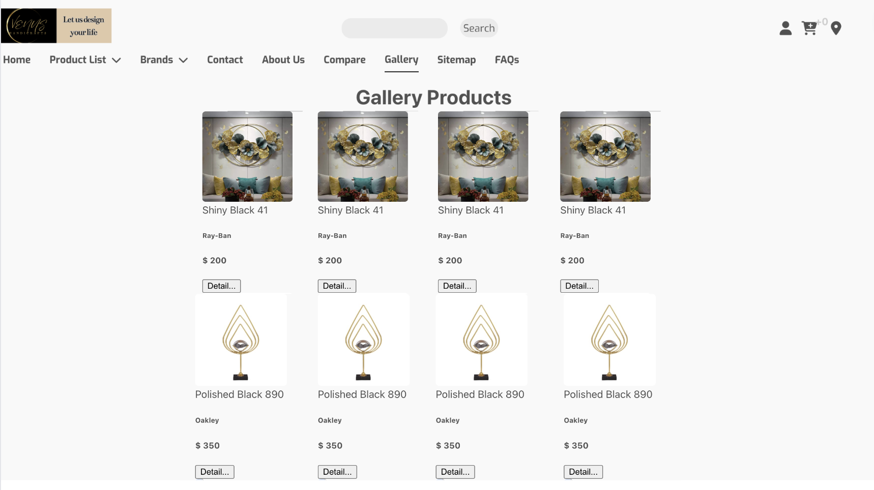

# SOURCE CODE

**HOMEPAGE**

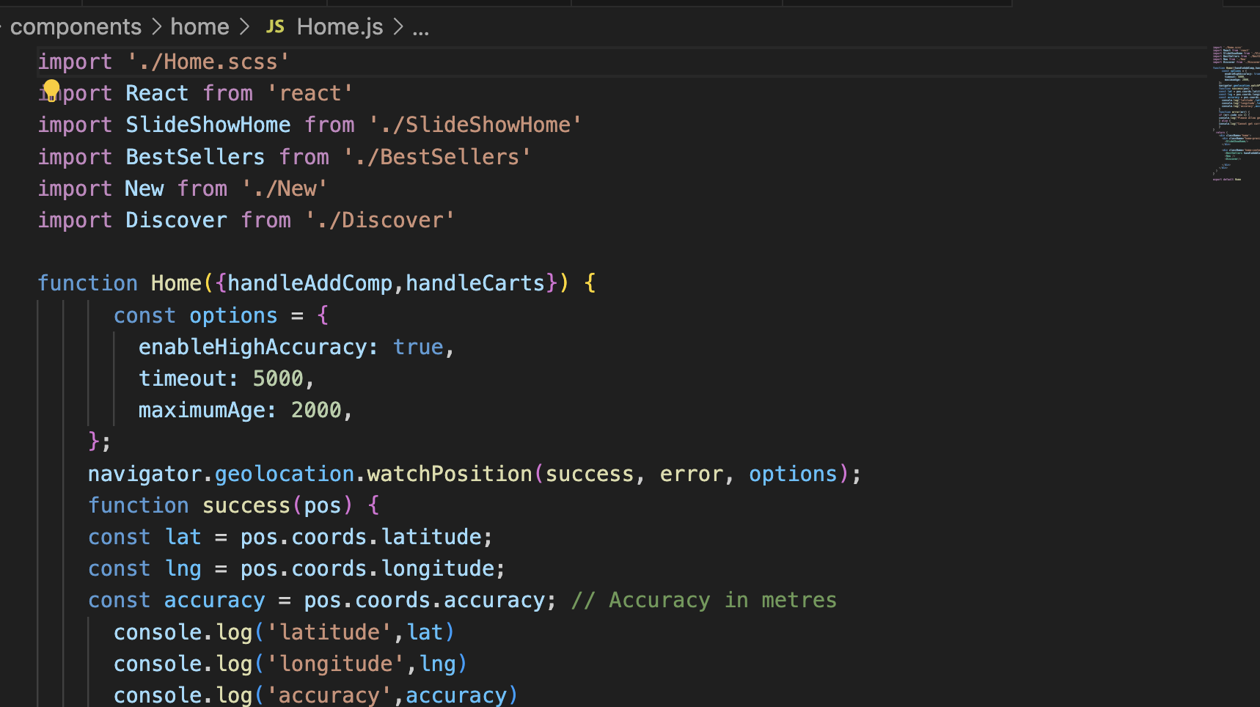

**SLIDESHOW**

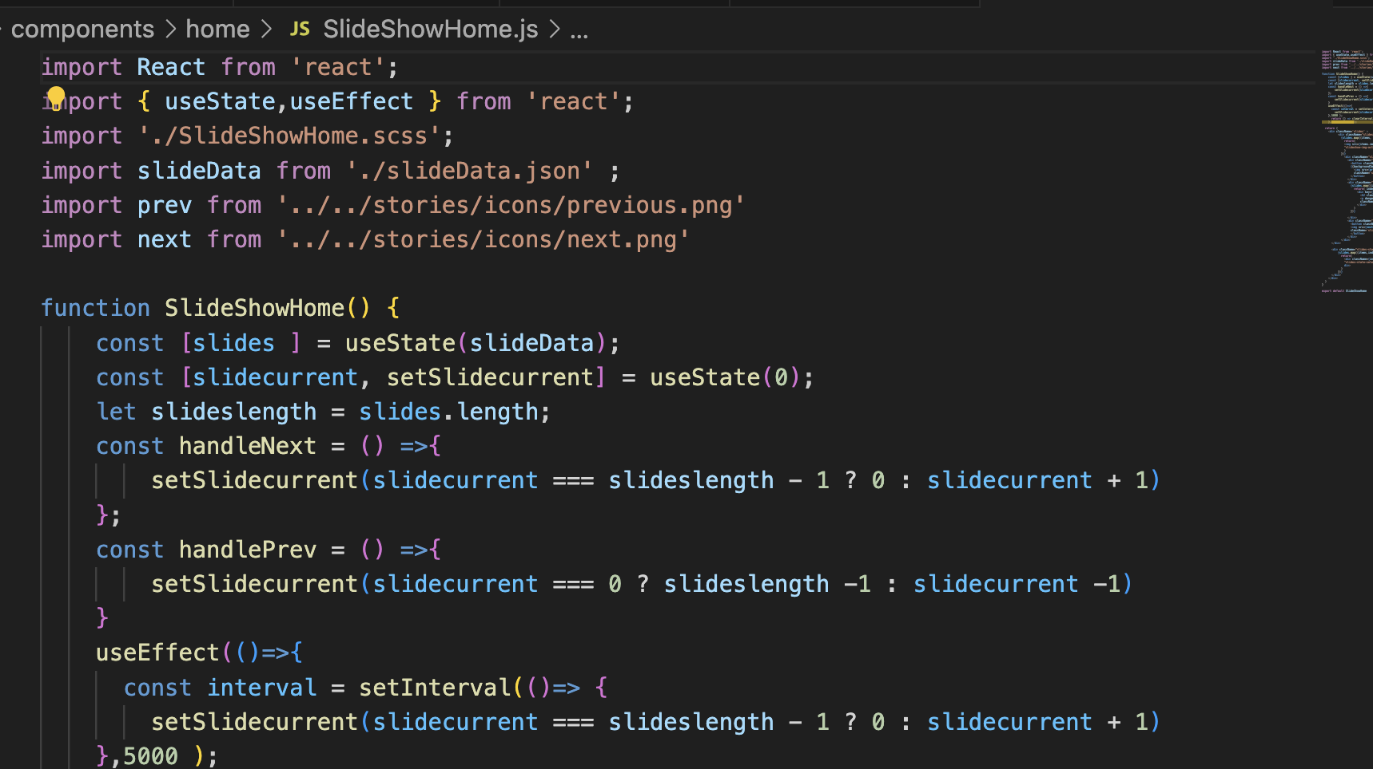

**BRANDS**

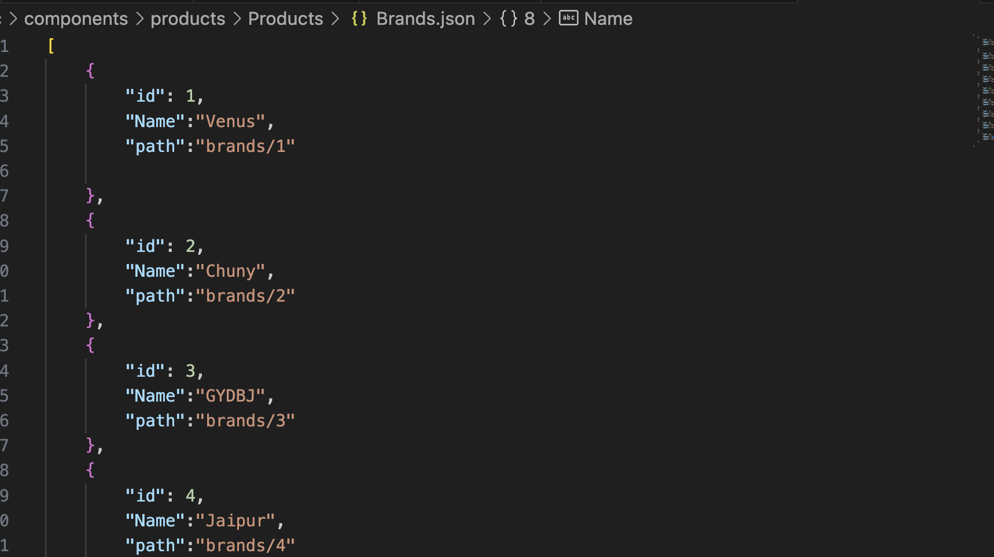

**PRODUCT JSON 1**

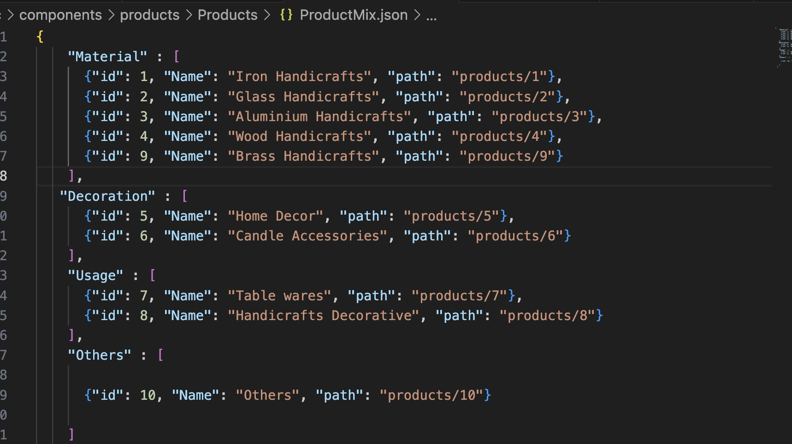

**PRODUCT JSON 2**

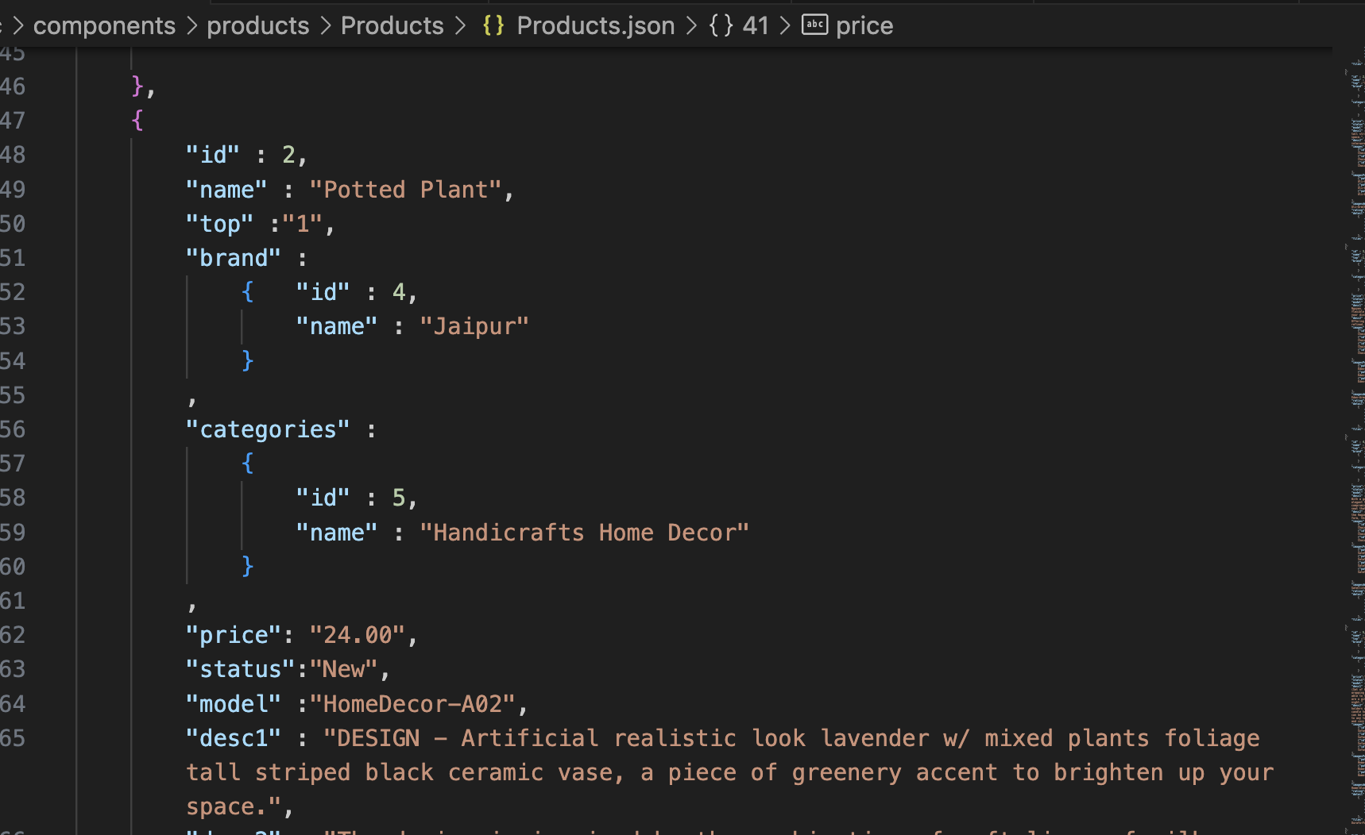

**ABOUT US**

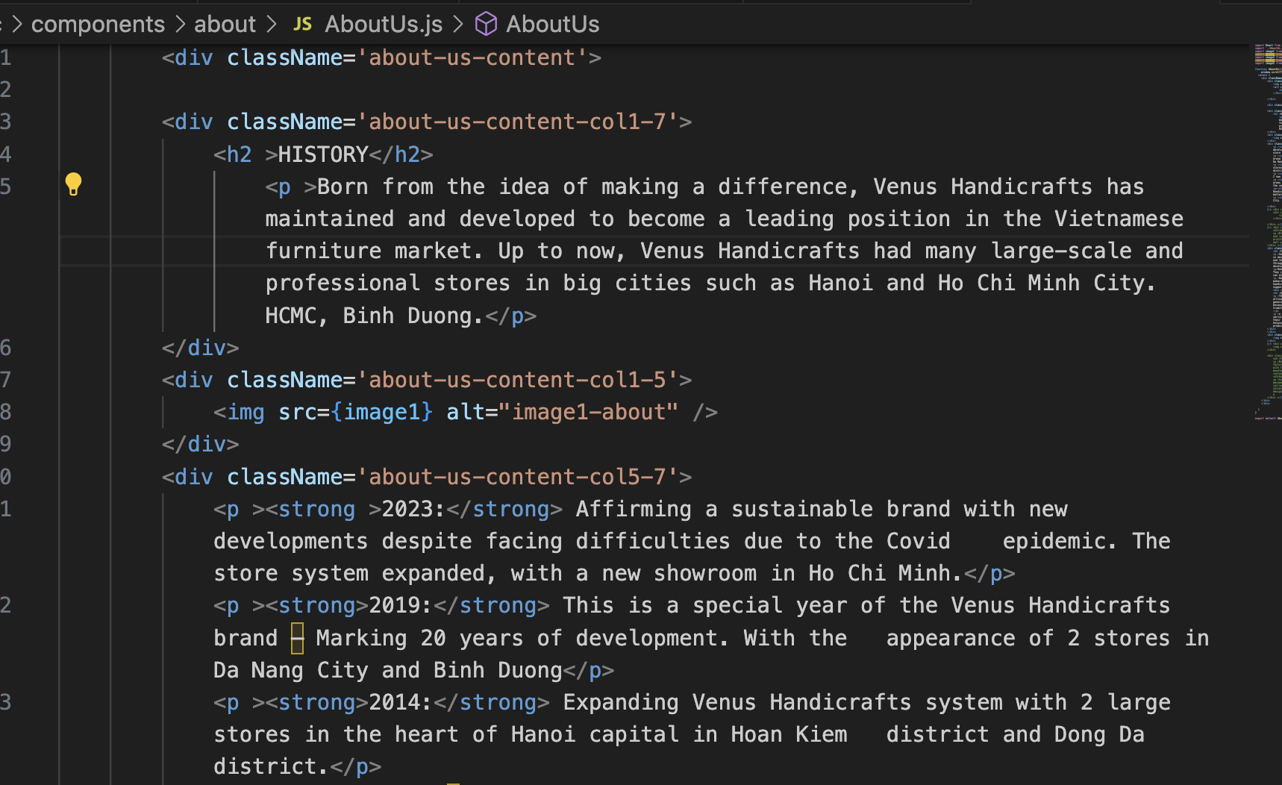

**CONTACT US**

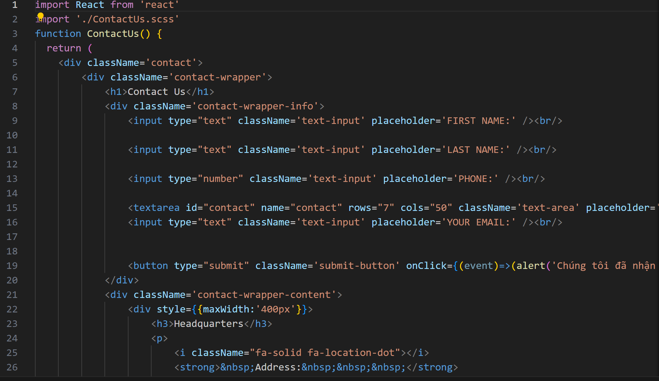

**GALLERY**

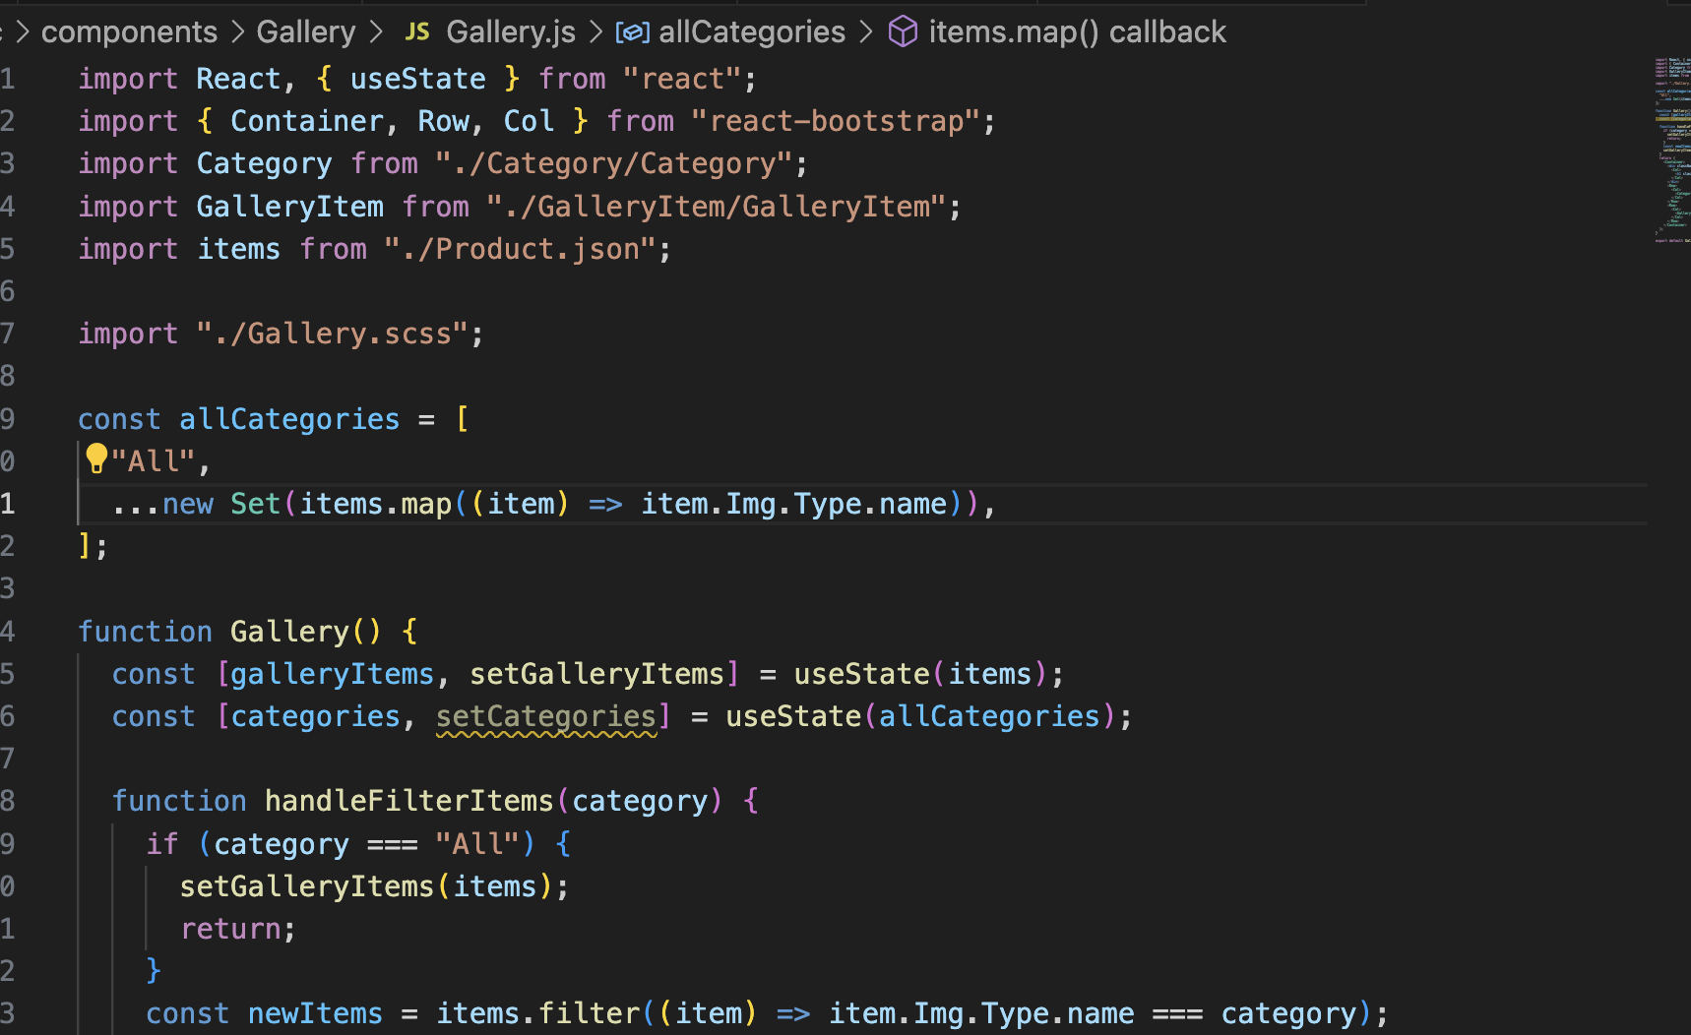

**COMPARE**

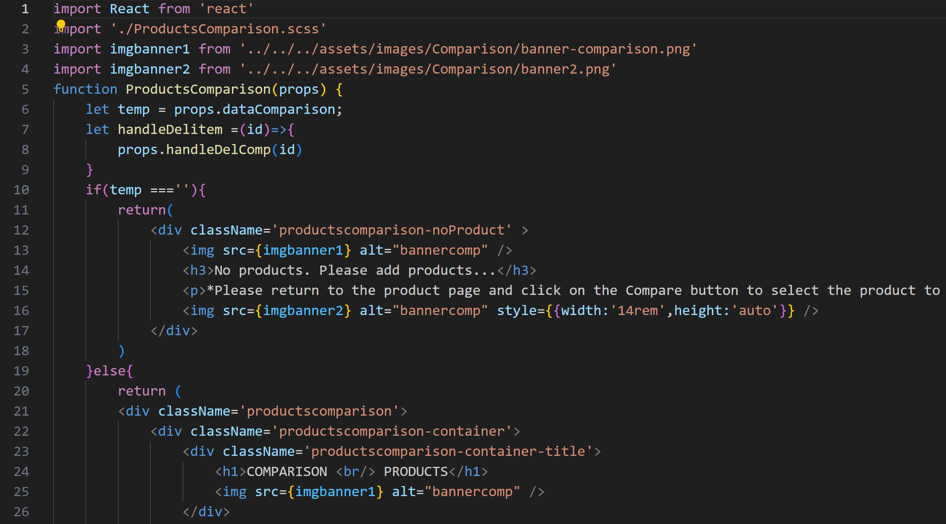

**FAQs**

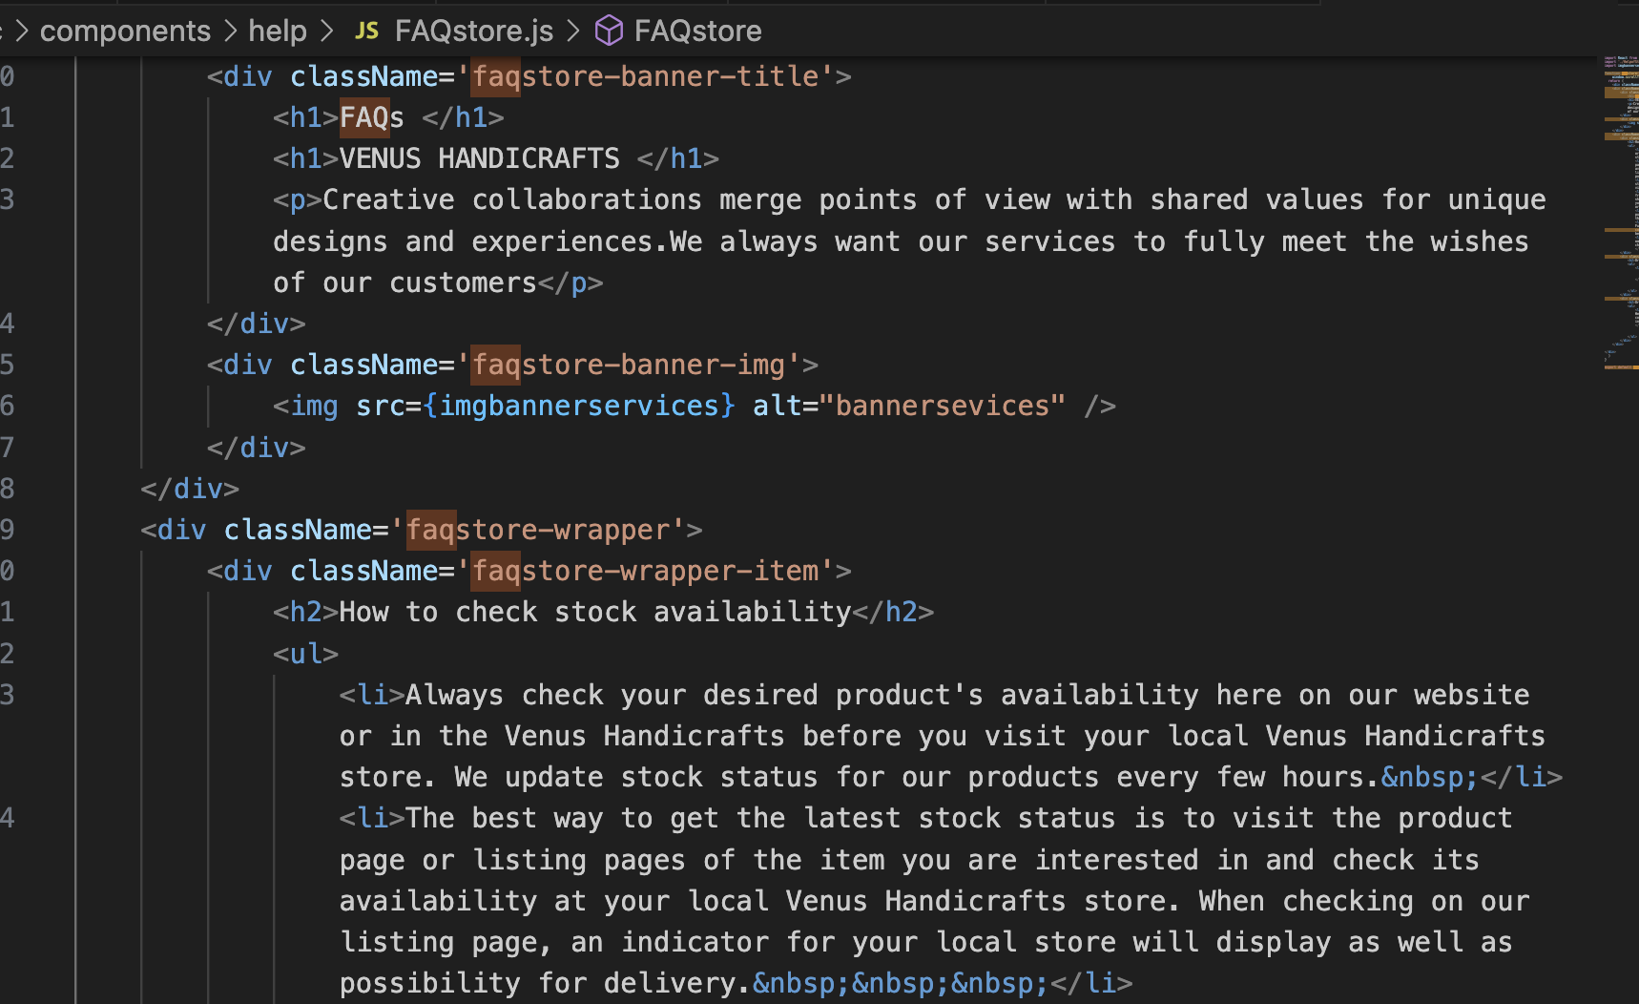

# TASK SHEET REVIEW 3

|  |  |  |  |  |  |  |  |
| --- | --- | --- | --- | --- | --- | --- | --- |
| **Project Ref. No.:**  **eP/Advertisement**  **Portal Management System/01** | | **Project Title:** | **Activity Plan Prepared By:** | **Date of Preparation of Activity Plan:** | | | |
| **Sr.**  **No.** | **Task** | **Actual**  **Start Date** | **Actual Days** | **Team**  **Mate Names** | **Status** |
| 1 | Home page | Venus Handicrafts | 04-Nov-2023 | 04-Nov-2023 | 1 | Triet, Viet, Khanh, Han | Completed |
| 2 | MenuDropdown01 | 04-Nov-2023 | 1 | Triet, Viet, Khanh, Han | Completed |
| 3 | MenuDropdown02 | 04-Nov-2023 | 1 | Triet, Viet, Khanh, Han | Completed |
| 4 | ProductsPage | 04-Nov-2023 | 1 | Triet, Viet, Khanh, Han | Completed |
| 5 | BrandsPage | 04-Nov-2023 | 1 | Triet, Viet, Khanh, Han | Completed |
| 6 | ProductDetail | 04-Nov-2023 | 1 | Triet, Viet, Khanh, Han | Completed |
| 7 | Sitemap | 04-Nov-2023 | 1 | Triet, Viet, Khanh, Han | Completed |
| 8 | Compare | 04-Nov-2023 | 1 | Triet, Viet, Khanh, Han | Completed |
| 9 | FAQs | 04-Nov-2023 | 1 | Triet, Viet, Khanh, Han | Completed |
| 10 | AboutUsPage | 04-Nov-2023 | 1 | Triet, Viet, Khanh, Han | Completed |
| 11 | ContactPage | 04-Nov-2023 | 1 | Triet, Viet, Khanh, Han | Completed |

|  |  |
| --- | --- |
| **Date: 05/10/2023** | |
| Signature of Instructor:  **Mr. Nguyen Phat Tai** | Signature of Team Leader:  **Ms. Le Thi Ngoc Han** |